AC I INDEX

|  |  |  |  |
| --- | --- | --- | --- |
| Sr. No. | Practical | Date | Sign |
| Practical No. 1 | Create a webpage to fetch and display the contents of a text file on click of a button using XMLHttpRequestObject. | 19/11/16 |  |
| Practical No. 2 | Create a web page using ajax to fetch text file contents on mouseover | 26/11/16 |  |
| Practical No. 3 | Create a webpage to fetch and display the image through a text file on click of a button using XMLHttpRequestObject | 3/12/16 |  |
| Practical No: 4 | Create a webpage to display the drop down menu using XMLHttpRequestObject. | 10/12/16 |  |
| Practical No: 5 | Create a webpage to capture data entered by user in a text field and display it in the webpage.form | 17/12/16 |  |
| Practical No: 6 | Create a webpage in php displaying the data | 14/1/17 |  |
| Practical No: 7 | Create a web page to fetch the matching name from the namearray stored in a php file using ajax when you enter the starting alphabet in a textfield. | 21/1/17 |  |
| Practical No: 8 | Create a html file to fetch the contents of cataglog.xml (CD details) using ajax and display them in a table. | 27/1/17 |  |
| Practical No: 9 | Create a html file to display a list box populated with usernames. On selecting a user name, corresponding details should be fetched from the table created in the backend. | 28/1/17 |  |

**PRACTICAL NO 1**

**AIM:** To create a webpage to fetch and display the contents of a text file on click of a button using XMLHttpRequestObject.

**INPUT:**

**Data.txt**

Hello Bina

<html>

<head>

<title>Ajax at work</title>

<script language="javascript">

var XMLHttpRequestObject=false;

if(window.XMLHttpRequest)

{

XMLHttpRequestObject=new XMLHttpRequest();

}

else if(window.ActiveXObject)

{

XMLHttpRequestObject=new ActiveXObject("Microsoft.XMLHTTP");

}

function getData(datasource,divId)

{

if(XMLHttpRequestObject)

{

var obj=document.getElementById(divId);

XMLHttpRequestObject.open("GET",datasource);

XMLHttpRequestObject.onreadystatechange=function()

{

if(XMLHttpRequestObject.readyState==4 &&

XMLHttpRequestObject.status==200)

{

obj.innerHTML=XMLHttpRequestObject.responseText;

}

}

XMLHttpRequestObject.send(null);

}

}

</script>

</head>

<body>

<h1>Fetching Data from Ajax</h1>

<form>

<input type="button" value="Display message" onclick="getData('data.txt','targetDiv')">

</form>

<div id="targetDiv">

<p>The fetched data will go here</p>

</div>

</body>

</html>

**OUTPUT:**

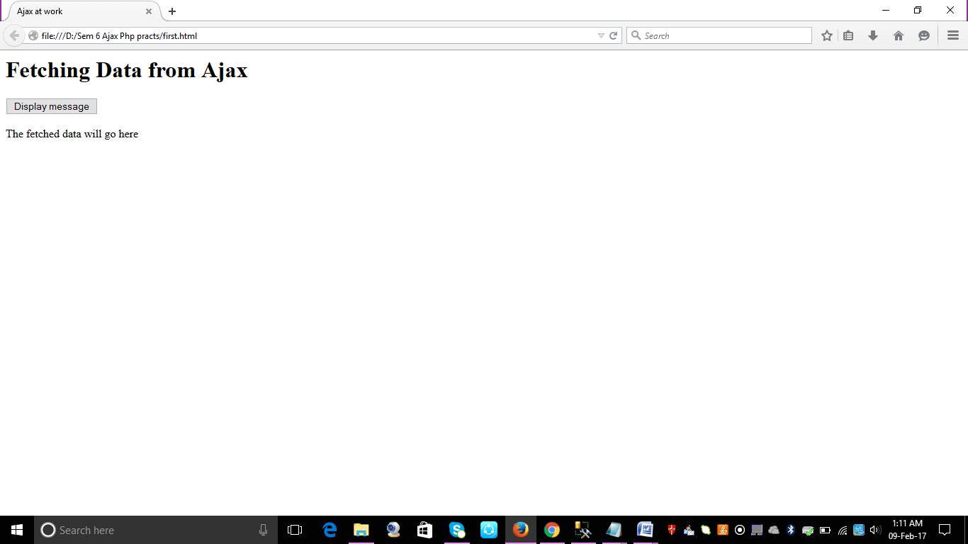

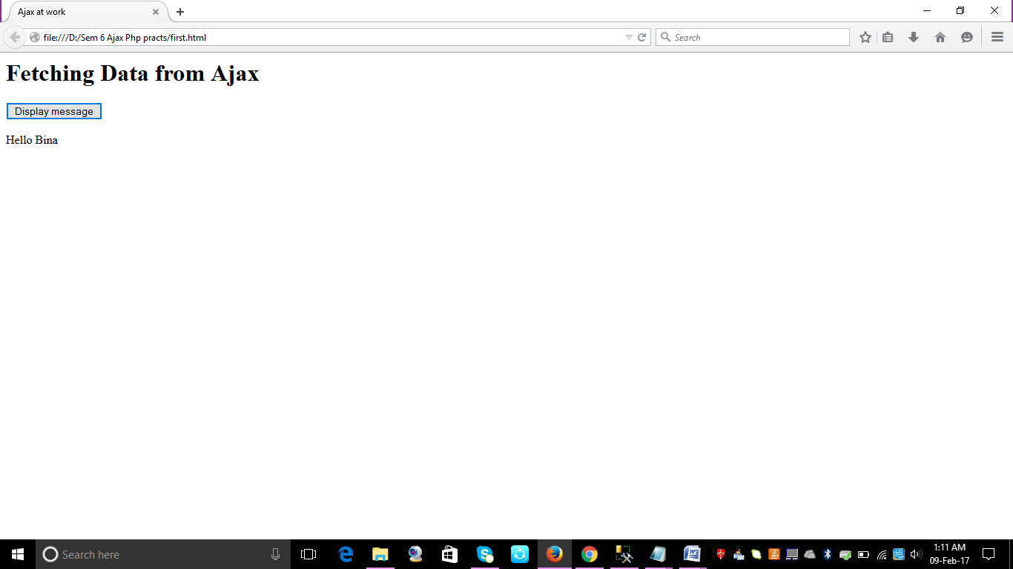

**PRACTICAL NO 2**

**AIM:** To create a web page using ajax to fetch text file contents on mouseover

**INPUT:**

<html>

<head>

<title>Ajax at work</title>

<script language="javascript">

var XMLHttpRequestObject=false;

if(window.XMLHttpRequest)

{

XMLHttpRequestObject=new XMLHttpRequest();

}

else if(window.ActiveXObject)

{

XMLHttpRequestObject=new ActiveXObject("Microsoft.XMLHTTP");

}

function getData(datasource,divId)

{

if(XMLHttpRequestObject)

{

var obj=document.getElementById(divId);

XMLHttpRequestObject.open("GET",datasource);

XMLHttpRequestObject.onreadystatechange=function()

{

if(XMLHttpRequestObject.readyState==4 &&

XMLHttpRequestObject.status==200)

{

obj.innerHTML=XMLHttpRequestObject.responseText;

}

}

XMLHttpRequestObject.send(null);

}

}

</script>

</head>

<body>

<h1>Displaying data from Ajax</h1>

<form>

<img src="BlueHills.jpg" height="80px"onmouseover="getData('Bh.txt','targetDiv')">

<img src="Flowers.jpg" height="80px" onmouseover="getData('f.txt','targetDiv')">

<img src="Sunset.jpg" height="80px" onmouseover="getData('s.txt','targetDiv')">

</form>

<div id="targetDiv">

<p>The fetched data will go here</p>

</div>

</body>

</html>

**OUTPUT:**

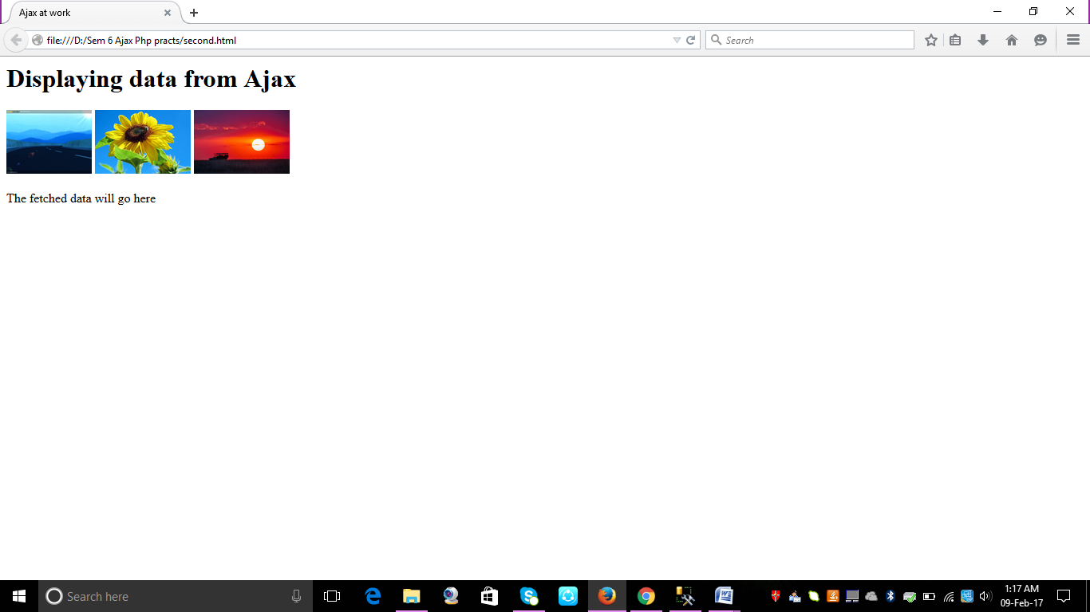

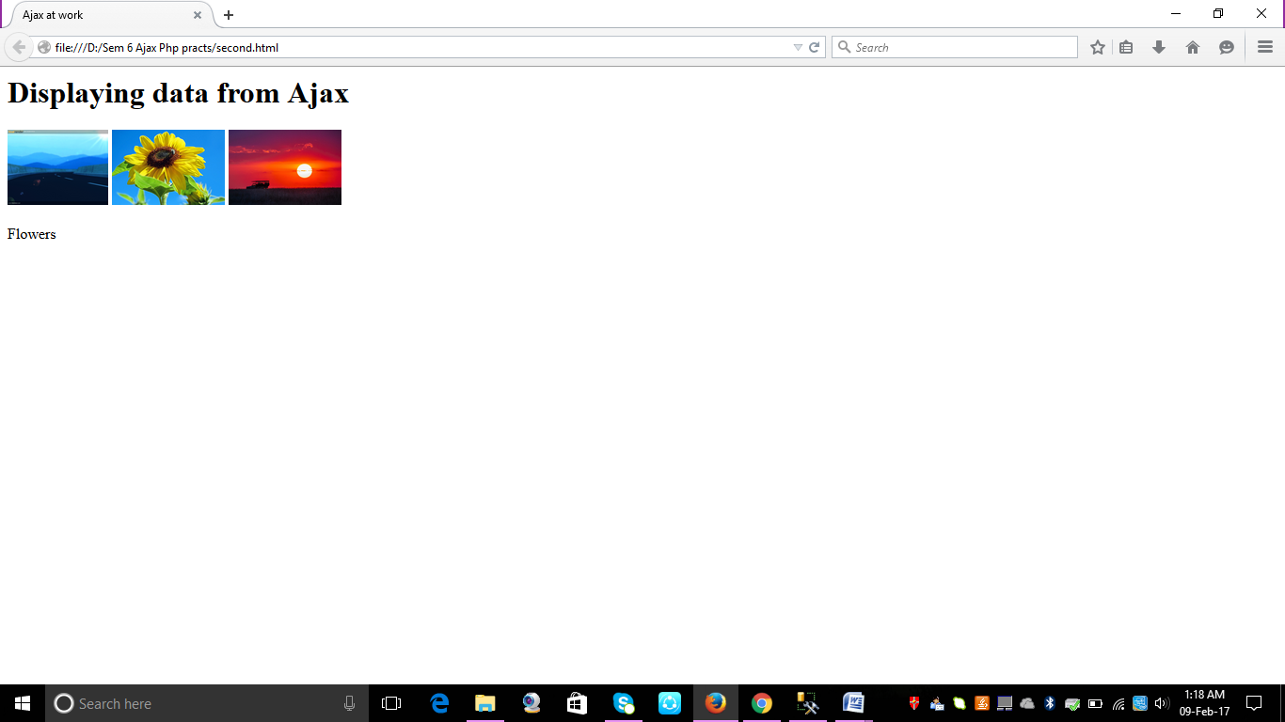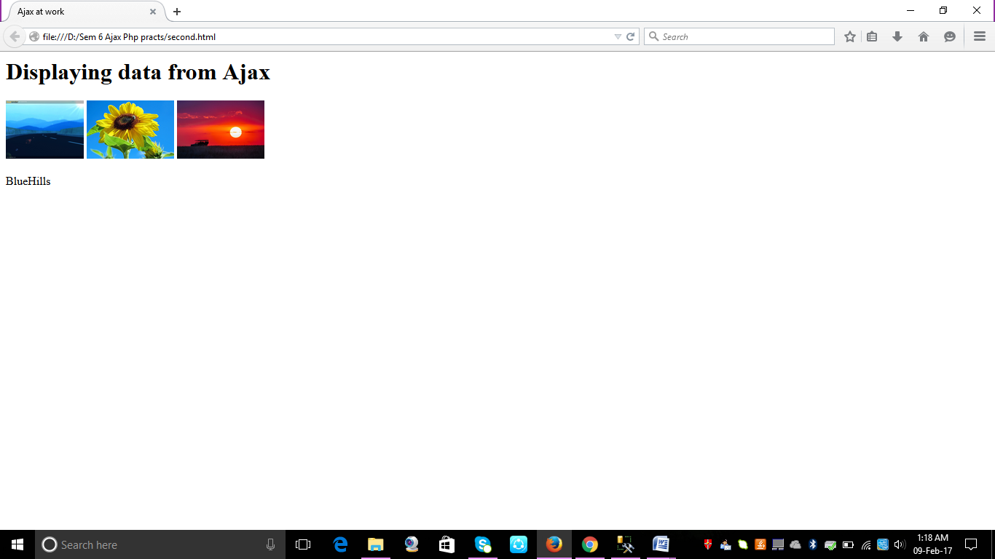

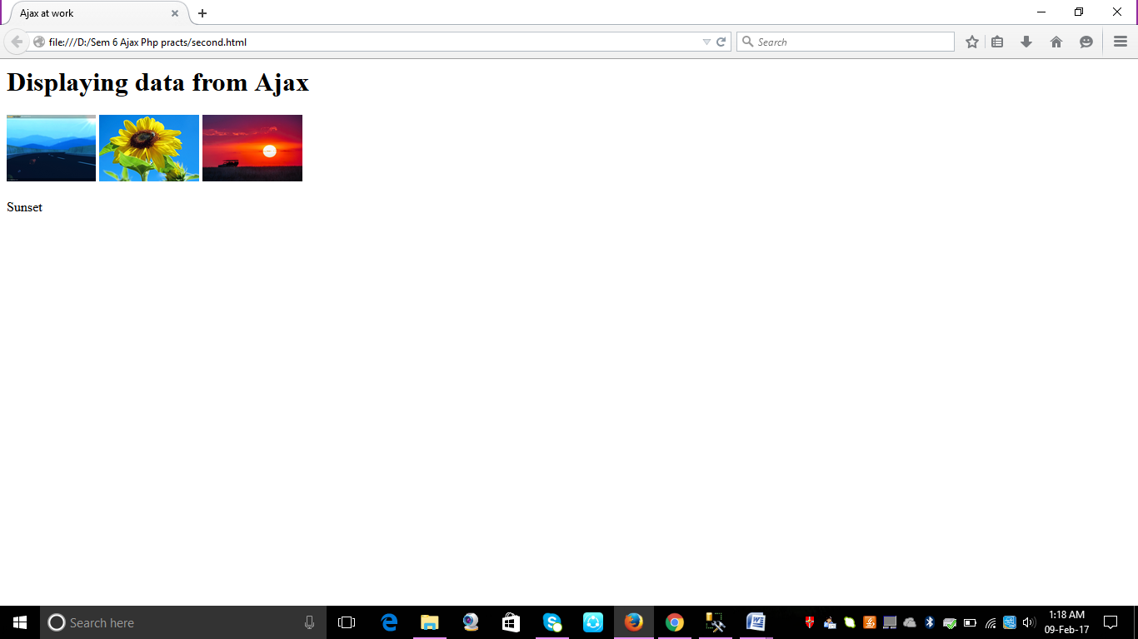

**PRACTICAL NO 3**

**AIM:** To create a webpage to fetch and display the image through a text file on click of a button using XMLHttpRequestObject

**INPUT:**

<html>

<head>

<title>Downloading images with Ajax and Dynamic HTML</title>

<script language = "javascript">

function getDataReturnText(dataSource, callback)

{

var XMLHttpRequestObject = false;

if (window.XMLHttpRequest) {

XMLHttpRequestObject = new XMLHttpRequest();

} else if (window.ActiveXObject) {

XMLHttpRequestObject = new

ActiveXObject("Microsoft.XMLHTTP");

}

if(XMLHttpRequestObject) {

XMLHttpRequestObject.open("GET", dataSource);

XMLHttpRequestObject.onreadystatechange = function()

{

if (XMLHttpRequestObject.readyState == 4 &&

XMLHttpRequestObject.status == 200) {

callback(XMLHttpRequestObject.responseText);

delete XMLHttpRequestObject;

XMLHttpRequestObject = null;

}

}

XMLHttpRequestObject.send(null);

}

}

function callback(text)

{

document.getElementById("targetDiv").innerHTML =

"<img src= " + text + ">";

}

</script>

</head>

<body>

<H1>Downloading images with Ajax and Dynamic HTML</H1>

<form>

<input type = "button" value = "Display Image 1"

onclick =

"getDataReturnText('imageName.txt', callback)">

<input type = "button" value = "Display Message 2"

onclick =

"getDataReturnText('imageName2.txt', callback)">

</form>

<div id="targetDiv">

<p>The fetched image will go here.</p>

</div>

</body>

</html>

**OUTPUT:**

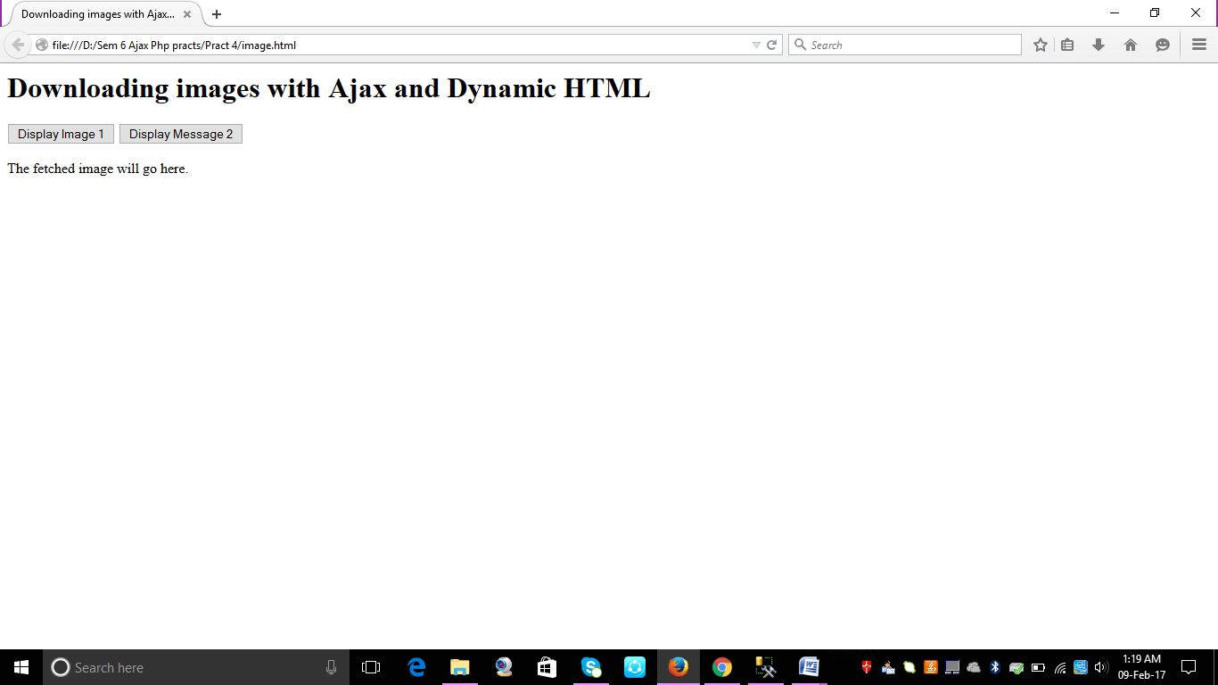

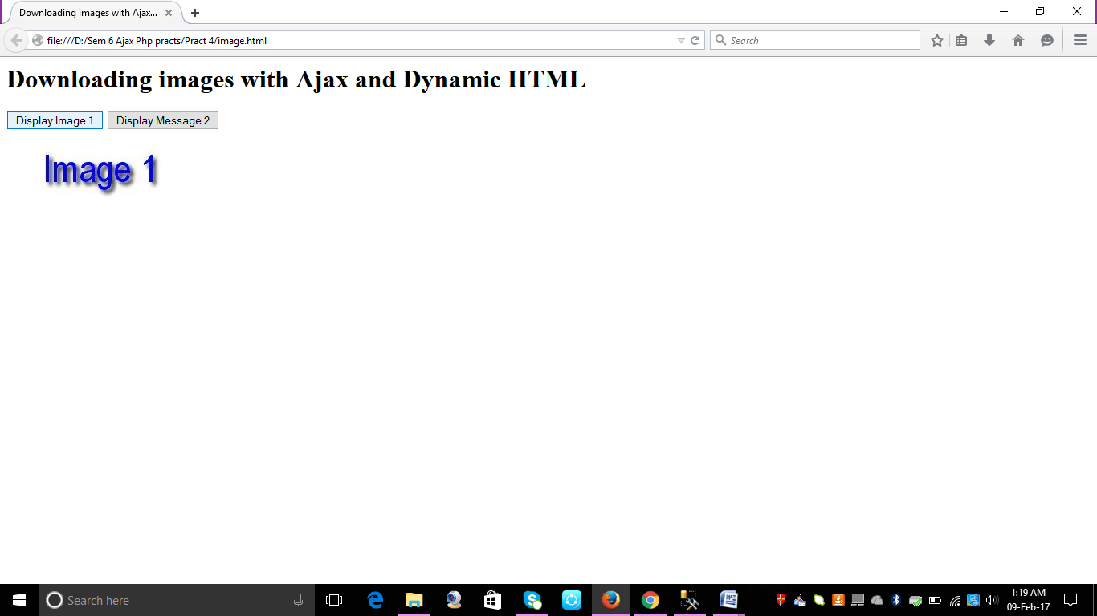

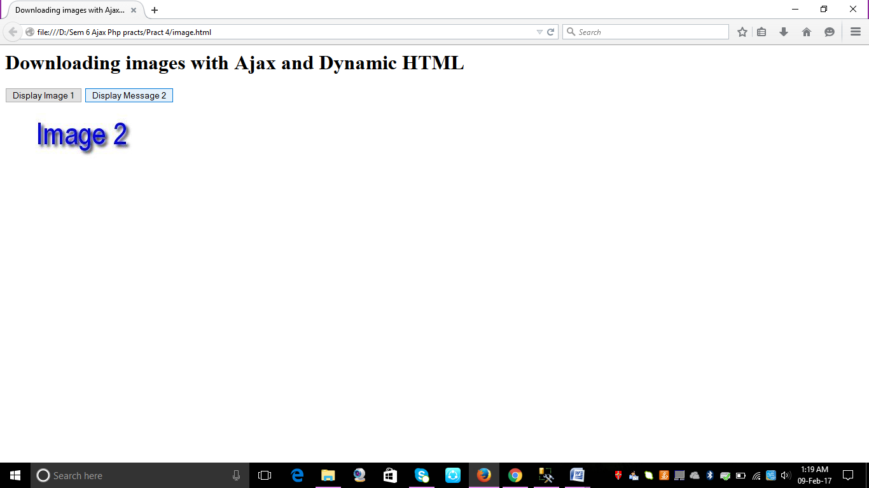

**PRACTICAL NO 4**

**AIM:** To create a webpage to display the drop down menu using XMLHttpRequestObject.

**INPUT:**

<html>

<head>

<title>Ajax-driven menus</title>

<style>

#menuDiv1 {

color: #222222;

background-color: #77CCFF;

font-weight: bold;

font-family: arial;

position: absolute;

visibility: hidden;

cursor: hand;

}

#menuDiv2 {

color: #222222;

background-color: #77CCFF;

font-weight: bold;

font-family: arial;

position: absolute;

visibility: hidden;

cursor: hand;

}

#targetDiv {

color: #990000;

font-size: 36pt;

font-weight: bold;

font-family: arial;

font-style: italic;

}

</style>

<script language = "javascript">

var arrayItems;

function getData(menu)

{

var XMLHttpRequestObject = false;

if (window.XMLHttpRequest) {

XMLHttpRequestObject = new XMLHttpRequest();

} else if (window.ActiveXObject) {

XMLHttpRequestObject = new

ActiveXObject("Microsoft.XMLHTTP");

}

var dataSource = (menu == 1) ? "items1.txt" : "items2.txt";

if(XMLHttpRequestObject) {

XMLHttpRequestObject.open("GET", dataSource);

XMLHttpRequestObject.onreadystatechange = function()

{

if (XMLHttpRequestObject.readyState == 4 &&

XMLHttpRequestObject.status == 200) {

show(menu, XMLHttpRequestObject.responseText);

}

}

XMLHttpRequestObject.send(null);

}

}

function show(menu, items)

{

var data = "<table width = '100%'>";

var loopIndex;

arrayItems = items.split(", ");

var target;

if (arrayItems.length != 0) {

for (var loopIndex = 0; loopIndex < arrayItems.length;

loopIndex++) {

var text = "display(" + loopIndex + ")";

data += "<tr><td "

+ "onclick='" + text + "'>" +

arrayItems[loopIndex] +

"</td></tr>";

}

}

data += "</table>";

if(menu == "1"){

target = document.getElementById("menuDiv1");

}

if(menu == "2"){

target = document.getElementById("menuDiv2");

}

if(target.style.visibility == "hidden"){

target.innerHTML = data;

target.style.visibility = "visible";

}

}

function hide()

{

var menuDiv1 = document.getElementById("menuDiv1");

if(menuDiv1.style.visibility == "visible"){

menuDiv1.innerHTML = "<div></div>";

menuDiv1.style.visibility = "hidden";

}

var menuDiv2 = document.getElementById("menuDiv2");

if(menuDiv2.style.visibility == "visible"){

menuDiv2.innerHTML = "<div></div>";

menuDiv2.style.visibility = "hidden";

}

}

function display(index)

{

var targetDiv = document.getElementById("targetDiv");

targetDiv.innerHTML = "You selected "

+ arrayItems[index] + ".";

}

function check(evt)

{

var e = new MouseEvent(evt);

var target = null;

var img;

img = document.getElementById("image1");

if((e.x > parseInt(img.style.left)) && (e.y >

parseInt(img.style.top)) &&

(e.x < (parseInt(img.style.left) +

parseInt(img.style.width)))

&& (e.y < (parseInt(img.style.top) +

parseInt (img.style.height)))){

getData(1);

}

img = document.getElementById("image2");

if(e.x > parseInt(img.style.left) && e.y >

parseInt(img.style.top) &&

e.x < (parseInt(img.style.left) +

parseInt(img.style.width))

&& e.y < (parseInt(img.style.top) +

parseInt(img.style.height))){

getData(2);

}

target = document.getElementById("menuDiv1");

img = document.getElementById("image1");

if (target.style.visibility == "visible"){

if(e.x < parseInt(target.style.left) || e.y <

parseInt(img.style.top) ||

e.x > (parseInt(img.style.left) +

parseInt(img.style.width))

|| e.y > (parseInt(target.style.top) +

parseInt(target.style.height))){

hide();

}

}

target = document.getElementById("menuDiv2");

img = document.getElementById("image2");

if (target.style.visibility == "visible"){

if(e.x < parseInt(target.style.left) || e.y <

parseInt(img.style.top) ||

e.x > (parseInt(img.style.left) +

parseInt(img.style.width))

|| e.y > (parseInt(target.style.top) +

parseInt(target.style.height))){

hide();

}

}

}

function MouseEvent(e)

{

if(e) {

this.e = e;

} else {

this.e = window.event;

}

if(e.pageX) {

this.x = e.pageX;

} else {

this.x = e.clientX;

}

if(e.pageY) {

this.y = e.pageY;

} else {

this.y = e.clientY;

}

if(e.target) {

this.target = e.target;

} else {

this.target = e.srcElement;

}

}

</script>

</head>

<body onclick = "hide()" onmousemove = "check(event)">

<H1>Ajax-driven menus</H1>

<img id = "image1" src="image1.jpg"

style="left:30; top:50; width:200; height:40;">

<div id = "menuDiv1" style="left:30; top:100; width:100;

height: 70; visibility:hidden;"><div></div></div>

<img id = "image2" style="left:270; top:50; width:200;

height:40;" src="image2.jpg">

<div id = "menuDiv2" style="left:270; top:100; width:100;

height: 70; visibility:hidden;"><div></div></div>

<div id = "targetDiv"></div>

</body>

</html>

**OUTPUT:**

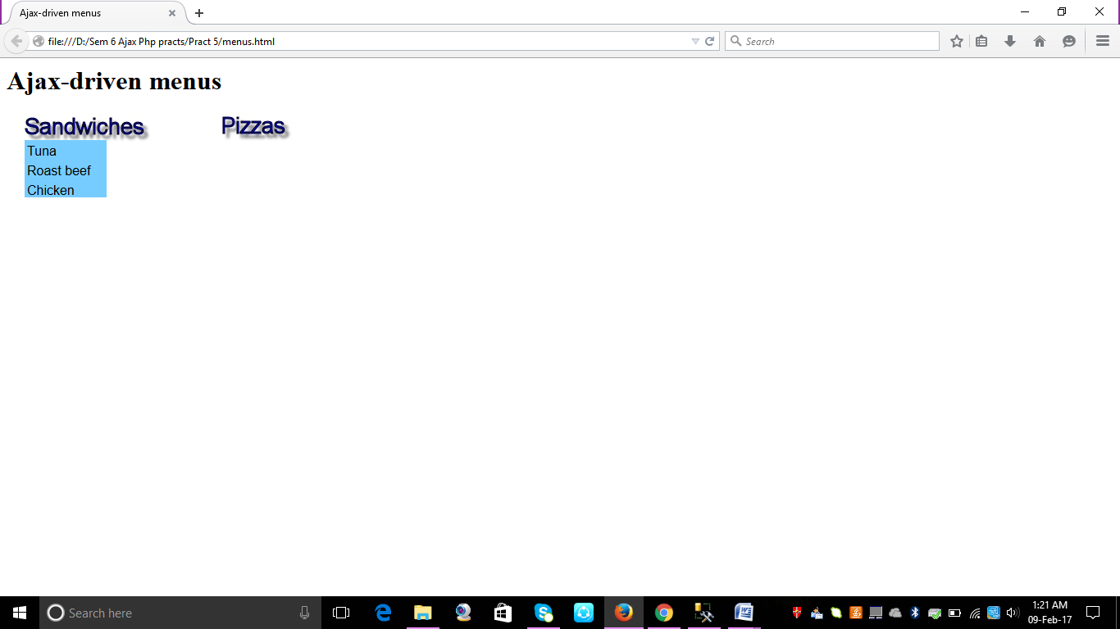 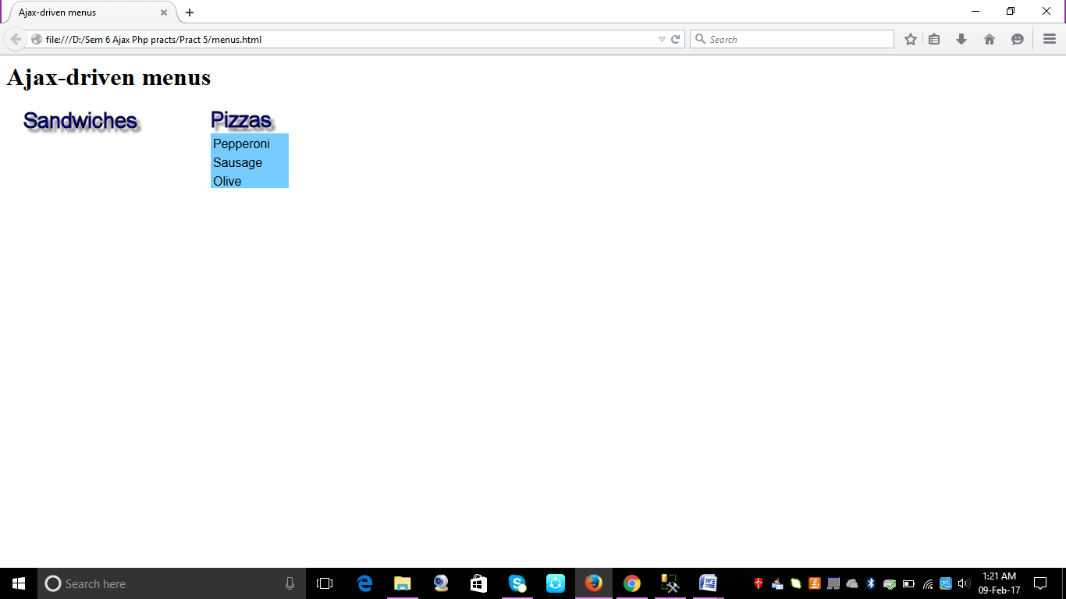

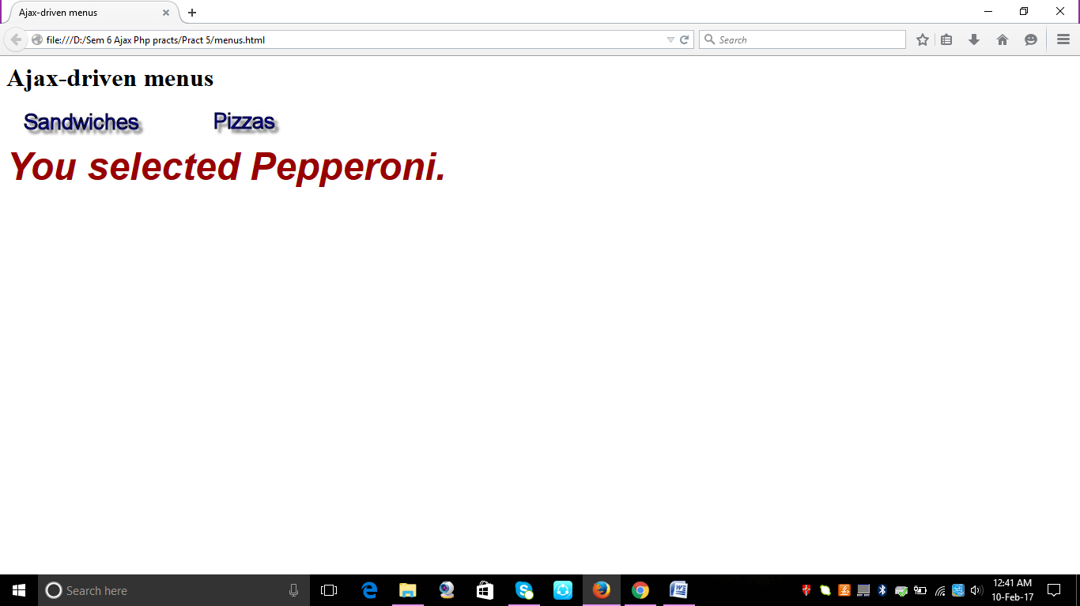 **PRACTICAL NO 5**

**AIM:** To create a webpage to capture data entered by user in a text field and display it in the webpage

**INPUT:**

<html>

<head>

<title> REGISTRATION FORM </title>

<script language="javascript">

function clearText()

{

document.getElementById('textName').value="";

document.getElementById('textDOB').value="";

document.getElementById('textAdd').value="";

document.getElementById('textEmail').value="";

document.getElementById('textMobile').value="";

}

</script>

</head>

<body>

<center> <h1> Registration Form </h1>

<form method="post" action="Display.php">

<table border="0" width="60%">

<tr height="40px">

<td width="200px"> Enter Name: </td>

<td>&nbsp; <input type="Text" name="txtName" id="textName"> </td>

</tr>

<tr height="40px">

<td>Enter DOB: </td>

<td>&nbsp; <input type="text" name="txtDOB" id="textDOB"> </td>

</tr>

<tr height="40px">

<td>Enter Address: </td>

<td>&nbsp; <textarea cols="40" rows="4" name="txtAdd" id="textAdd"> </textarea></td>

</tr>

<tr height="40px">

<td>Enter e-mail id: </td>

<td>&nbsp; <input type="text" name="txtemail" id="textEmail"> </td>

</tr>

<tr height="40px">

<td>Enter Mobile No: </td>

<td>&nbsp; <input type="text" name="txtMobile" id="textMobile"> </td>

</tr>

<tr height="40px">

<td align="center"><input type="Submit" value="Submit"></td>

<td align="center"><input type="Button" value="Reset" onClick="clearText()"> </td>

</tr>

</table>

</center>

</form>

</body>

</html>

Display.php

<html>

<head>

<title> DISPLAYING REGITRATION DETAILS USING PHP </title>

</head>

<body>

<center>

<h1> READING VALUES FROM THE REGISTRATION FROM AND DISPLAYING ON THIS FORM </h1>

<table border="1" width="60%">

<tr height="50px">

<td>Name: </td>

<td>&nbsp; <?php echo $_REQUEST["txtName"]; ?></td>

</tr>

<tr height="50px">

<td>Birth Date: </td>

<td>&nbsp; <?php echo $_REQUEST["txtDOB"]; ?></td>

</tr>

<tr height="50px">

<td>Address: </td>

<td>&nbsp; <?php echo $_REQUEST["txtAdd"]; ?></td>

</tr>

<tr height="50px">

<td>E-mail ID: </td>

<td>&nbsp; <?php echo $_REQUEST["txtemail"]; ?></td>

</tr>

<tr height="50px">

<td>Mobile No: </td>

<td>&nbsp; <?php echo $_REQUEST["txtMobile"]; ?></td>

</tr>

</center>

</body>

</html>

**OUTPUT:**

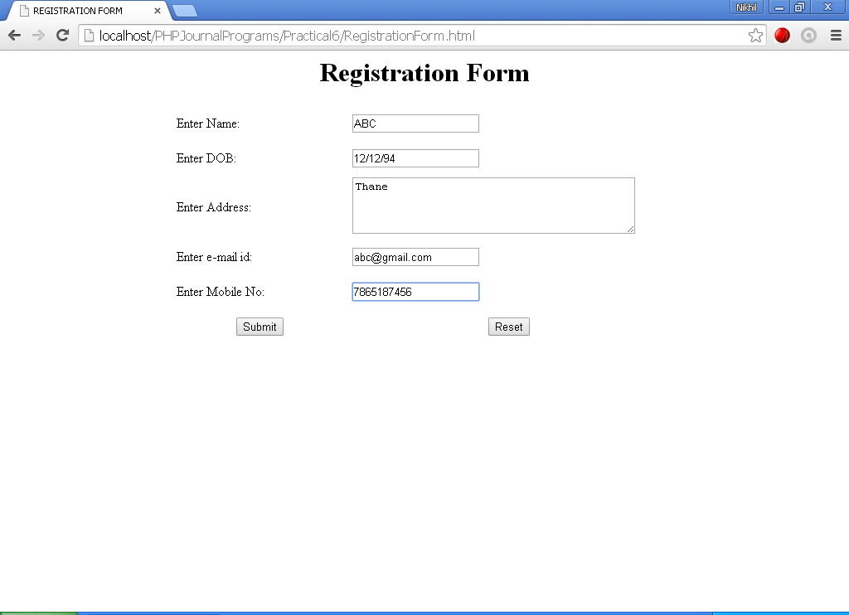

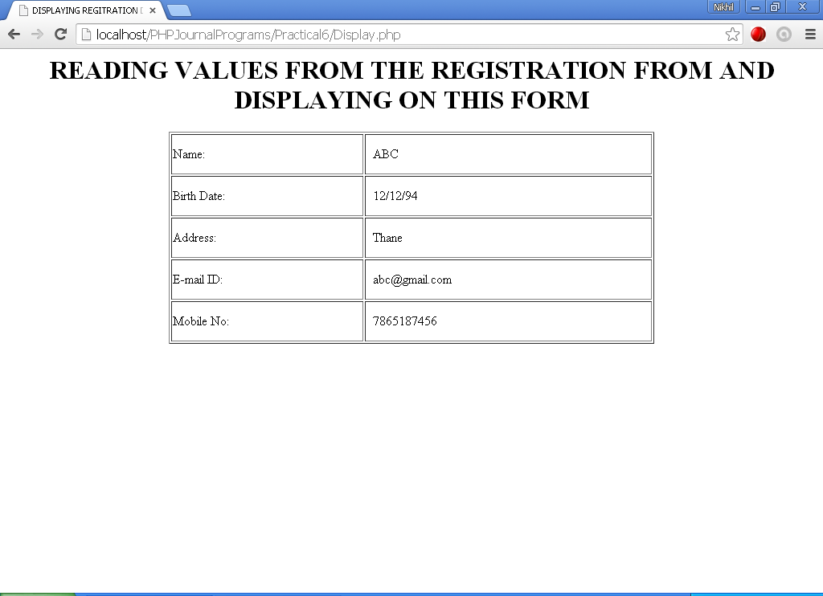

**PRACTICAL NO 6**

**AIM:** To create a webpage in php displaying the data

**INPUT:**

<html>

<head>

<title>PHP test</title>

</head>

<body>

<?php echo '<p> Welcome to world of PHP</p>';?>

</body>

</html>

**OUTPUT:**

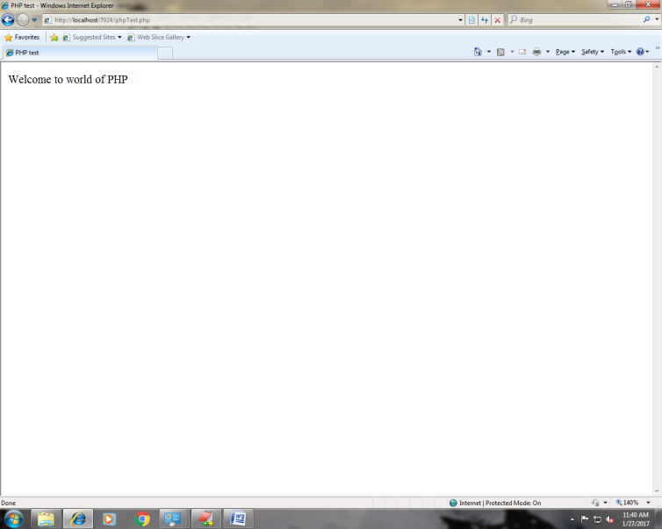

**PRACTICAL NO 7**

**AIM:** To create a web page to fetch the matching name from the namearray stored in a php file using ajax when you enter the starting alphabet in a textfield

**INPUT:**

<html>

<head>

<script type=""text/javascript">

function showMatches(str)

{

document.getElementById("text").innerHTML=str;

if(str.length==0)

{

document.getElementById("txtHint").innerHTML="";

document.getElementById("Match").innerHTML="";

document.getElementById("text").innerHTML="";

return;

}

if(window.XMLHttpRequest)

{

xmlhttp=new XMLHttpRequest();

}

else

{

xmlhttp=new ActiveXObject("Microsoft.XMLHTTP");

}

xmlhttp.onreadystatechange=function()

{

if (xmlhttp.readyState == 4 && xmlhttp.status == 200)

{

document.getElementById("Match").innerHTML=xmlhttp.responseText;

}

}

xmlhttp.open("GET","Names.php?q="+str,true);

xmlhttp.send();

}

</script>

</head>

<body>

<p><h1>Start typing a name in the input field below</h1></p>

<form>

First Name:<input type="text" onkeyup="showMatches(this.value)" size="20"/>

</form>

<p>Matching suggestions<span id="Match"></span></p>

<p>Text Entered is:<span id="text"></span></p>

</body>

</html>

Names.php

<?php

$a[]="Anita";

$a[]="Bhaskar";

$a[]="Chirag";

$a[]="Diana";

$a[]="Eva";

$a[]="Fiona";

$a[]="Anil";

$a[]="Gayatri";

$a[]="Sneha";

$a[]="Kokil";

$a[]="Heena";

$a[]="Isha";

$a[]="Bharat";

$a[]="Jigna";

$a[]="Kamal";

$a[]="Leena";

$a[]="Chiranjeev";

$a[]="Anirudh";

$a[]="Nina";

$a[]="Ophelia";

$a[]="Padmini";

$a[]="Akansha";

$a[]="Bhavana";

$a[]="Aishwarya";

$a[]="Tejal";

$a[]="Abhay";

$a[]="Dev";

$a[]="Ritesh";

$a[]="Deepal";

$a[]="Kalpesh";

$a[]="Harsh";

$q=$_GET["q"];

if (strlen($q)>0)

{

$match="";

for($i=0; $i<count($a); $i++)

{

if (strtolower($q) == strtolower(substr($a[$i],0,strlen($q))))

{

if($match=="")

{

$match=$a[$i];

}

else

{

$match=$match. "," .$a[$i];

}

}

}

}

//set output to "No Match Found"

if($match=="")

{

$response="no suggestion";

}

else

{

$response=$match;

}

//output the response

echo $response;

?>

**OUTPUT:**

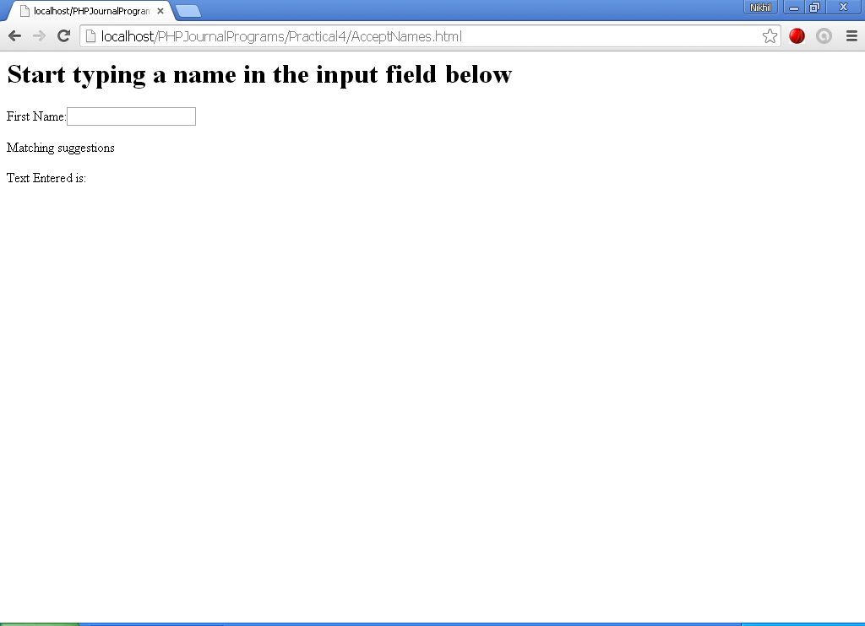

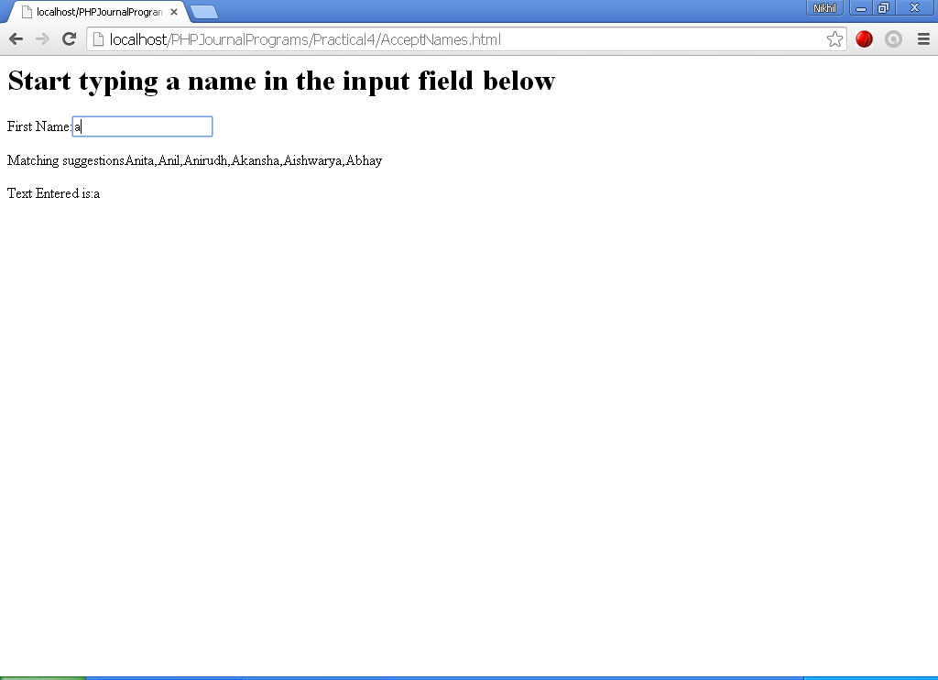

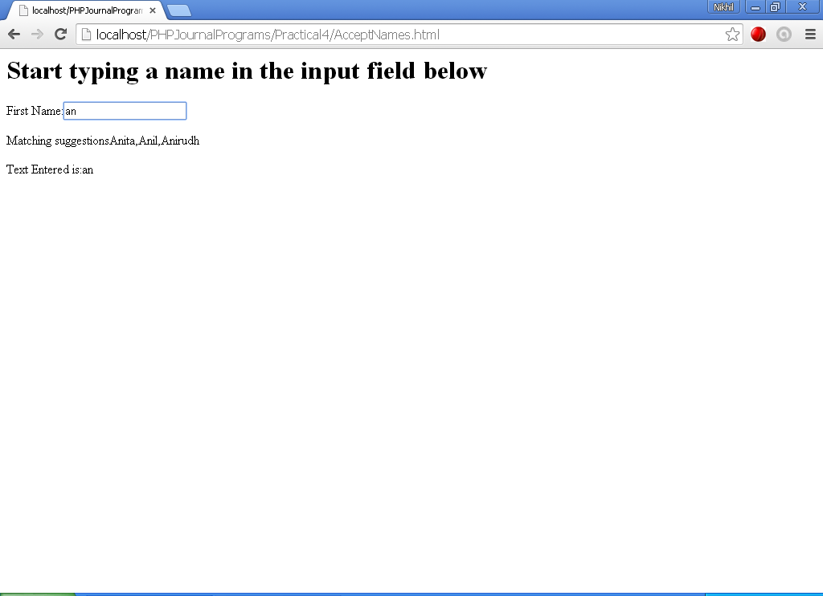

**PRACTICAL NO 8**

**AIM:** To create a html file to fetch the contents of cataglog.xml (CD details) using ajax and display them in a table

**INPUT:**

**catalog.xml**

<CATALOG>

<CD>

<TITLE>Empire Burlesque</TITLE>

<ARTIST>Bob Dylan</ARTIST>

<COUNTRY>USA</COUNTRY>

<COMPANY>Columbia</COMPANY>

<PRICE>10.90</PRICE>

<YEAR>1985</YEAR>

</CD>

<CD>

<TITLE>Hide your heart</TITLE>

<ARTIST>Bonnie Tyler</ARTIST>

<COUNTRY>UK</COUNTRY>

<COMPANY>CBS Records</COMPANY>

<PRICE>9.90</PRICE>

<YEAR>1988</YEAR>

</CD>

<CD>

<TITLE>Greatest Hits</TITLE>

<ARTIST>Dolly Parton</ARTIST>

<COUNTRY>USA</COUNTRY>

<COMPANY>RCA</COMPANY>

<PRICE>9.90</PRICE>

<YEAR>1982</YEAR>

</CD>

<CD>

<TITLE>Still got the blues</TITLE>

<ARTIST>Gary Moore</ARTIST>

<COUNTRY>UK</COUNTRY>

<COMPANY>Virgin records</COMPANY>

<PRICE>10.20</PRICE>

<YEAR>1990</YEAR>

</CD>

<CD>

<TITLE>Eros</TITLE>

<ARTIST>Eros Ramazzotti</ARTIST>

<COUNTRY>EU</COUNTRY>

<COMPANY>BMG</COMPANY>

<PRICE>9.90</PRICE>

<YEAR>1997</YEAR>

</CD>

<CD>

<TITLE>One night only</TITLE>

<ARTIST>Bee Gees</ARTIST>

<COUNTRY>UK</COUNTRY>

<COMPANY>Polydor</COMPANY>

<PRICE>10.90</PRICE>

<YEAR>1998</YEAR>

</CD>

<CD>

<TITLE>Sylvias Mother</TITLE>

<ARTIST>Dr.Hook</ARTIST>

<COUNTRY>UK</COUNTRY>

<COMPANY>CBS</COMPANY>

<PRICE>8.10</PRICE>

<YEAR>1973</YEAR>

</CD>

<CD>

<TITLE>Maggie May</TITLE>

<ARTIST>Rod Stewart</ARTIST>

<COUNTRY>UK</COUNTRY>

<COMPANY>Pickwick</COMPANY>

<PRICE>8.50</PRICE>

<YEAR>1990</YEAR>

</CD>

<CD>

<TITLE>Romanza</TITLE>

<ARTIST>Andrea Bocelli</ARTIST>

<COUNTRY>EU</COUNTRY>

<COMPANY>Polydor</COMPANY>

<PRICE>10.80</PRICE>

<YEAR>1996</YEAR>

</CD>

<CD>

<TITLE>When a man loves a woman</TITLE>

<ARTIST>Percy Sledge</ARTIST>

<COUNTRY>USA</COUNTRY>

<COMPANY>Atlantic</COMPANY>

<PRICE>8.70</PRICE>

<YEAR>1987</YEAR>

</CD>

<CD>

<TITLE>Black angel</TITLE>

<ARTIST>Savage Rose</ARTIST>

<COUNTRY>EU</COUNTRY>

<COMPANY>Mega</COMPANY>

<PRICE>10.90</PRICE>

<YEAR>1995</YEAR>

</CD>

<CD>

<TITLE>1999 Grammy Nominees</TITLE>

<ARTIST>Many</ARTIST>

<COUNTRY>USA</COUNTRY>

<COMPANY>Grammy</COMPANY>

<PRICE>10.20</PRICE>

<YEAR>1999</YEAR>

</CD>

<CD>

<TITLE>For the good times</TITLE>

<ARTIST>Kenny Rogers</ARTIST>

<COUNTRY>UK</COUNTRY>

<COMPANY>Mucik Master</COMPANY>

<PRICE>8.70</PRICE>

<YEAR>1995</YEAR>

</CD>

<CD>

<TITLE>Big Willie style</TITLE>

0 <ARTIST>Will Smith</ARTIST>

<COUNTRY>USA</COUNTRY>

<COMPANY>Columbia</COMPANY>

<PRICE>9.90</PRICE>

<YEAR>1997</YEAR>

</CD>

<CD>

<TITLE>Tupelo Honey</TITLE>

<ARTIST>Van Morrison</ARTIST>

<COUNTRY>UK</COUNTRY>

<COMPANY>Polydor</COMPANY>

<PRICE>8.20</PRICE>

<YEAR>1971</YEAR>

</CD>

<CD>

<TITLE>Soulsville</TITLE>

<ARTIST>Jorn Hoel</ARTIST>

<COUNTRY>Norway</COUNTRY>

<COMPANY>WEA</COMPANY>

<PRICE>7.90</PRICE>

<YEAR>1996</YEAR>

</CD>

<CD>

<TITLE>The very best of</TITLE>

<ARTIST>Cat Stevens</ARTIST>

<COUNTRY>UK</COUNTRY>

<COMPANY>Island</COMPANY>

<PRICE>8.90</PRICE>

<YEAR>1990</YEAR>

</CD>

<CD>

<TITLE>Stop</TITLE>

<ARTIST>Sam Brown</ARTIST>

<COUNTRY>UK</COUNTRY>

<COMPANY>A and M</COMPANY>

<PRICE>8.90</PRICE>

<YEAR>1988</YEAR>

</CD>

<CD>

<TITLE>Bridge of Spies</TITLE>

<ARTIST>T'Pau</ARTIST>

<COUNTRY>UK</COUNTRY>

<COMPANY>Siren</COMPANY>

<PRICE>7.90</PRICE>

<YEAR>1987</YEAR>

</CD>

<CD>

<TITLE>Private Dancer</TITLE>

<ARTIST>Tina Turner</ARTIST>

<COUNTRY>UK</COUNTRY>

<COMPANY>Capitol</COMPANY>

<PRICE>8.90</PRICE>

<YEAR>1983</YEAR>

</CD>

<CD>

<TITLE>Midt om natten</TITLE>

<ARTIST>Kim Larsen</ARTIST>

<COUNTRY>EU</COUNTRY>

<COMPANY>Medley</COMPANY>

<PRICE>7.80</PRICE>

<YEAR>1983</YEAR>

</CD>

<CD>

<TITLE>Pavarotti Gala Concert</TITLE>

<ARTIST>Luciano Pavarotti</ARTIST>

<COUNTRY>UK</COUNTRY>

<COMPANY>DECCA</COMPANY>

<PRICE>9.90</PRICE>

<YEAR>1991</YEAR>

</CD>

<CD>

<TITLE>The dock of the bay</TITLE>

<ARTIST>Otis Redding</ARTIST>

<COUNTRY>USA</COUNTRY>

<COMPANY>Atlantic</COMPANY>

<PRICE>7.90</PRICE>

<YEAR>1987</YEAR>

</CD>

<CD>

<TITLE>Picture book</TITLE>

<ARTIST>Simply Red</ARTIST>

<COUNTRY>EU</COUNTRY>

<COMPANY>Elektra</COMPANY>

<PRICE>7.20</PRICE>

<YEAR>1985</YEAR>

</CD>

<CD>

<TITLE>Red</TITLE>

<ARTIST>The Communards</ARTIST>

<COUNTRY>UK</COUNTRY>

<COMPANY>London</COMPANY>

<PRICE>7.80</PRICE>

<YEAR>1987</YEAR>

</CD>

<CD>

<TITLE>Unchain my heart</TITLE>

<ARTIST>Joe Cocker</ARTIST>

<COUNTRY>USA</COUNTRY>

<COMPANY>EMI</COMPANY>

<PRICE>8.20</PRICE>

<YEAR>1987</YEAR>

</CD>

</CATALOG>

<html>

<head>

<script type="text/javascript">

var xmlhttp;

function loadXMLDoc(url)

{

xmlhttp=null;

if (window.XMLHttpRequest)

{// code for IE7+, Firefox, Chrome, Opera, Safari

xmlhttp=new XMLHttpRequest();

}

else

{// code for IE5, IE6

xmlhttp=new ActiveXObject("Microsoft.XMLHTTP");

}

xmlhttp.onreadystatechange=onResponse;

xmlhttp.open("GET",url,true);

xmlhttp.send(null);

}

function onResponse()

{

if(xmlhttp.readyState!=4) return;

if(xmlhttp.status!=200)

{

alert("Problem retrieving XML data");

return;

}

txt="<table border='1'>";

x=xmlhttp.responseXML.documentElement.getElementsByTagName("CD");

for (i=0;i<x.length;i++)

{

txt=txt + "<tr>";

xx=x[i].getElementsByTagName("TITLE");

{

try

{

txt=txt + "<td>" + xx[0].firstChild.nodeValue + "</td>";

}

catch (er)

{

txt=txt + "<td> </td>";

}

}

xx=x[i].getElementsByTagName("ARTIST");

{

try

{

txt=txt + "<td>" + xx[0].firstChild.nodeValue + "</td>";

}

catch (er)

{

txt=txt + "<td> </td>";

}

}

txt=txt + "</tr>";

}

txt=txt + "</table>";

document.getElementById('copy').innerHTML=txt;

}

</script>

</head>

<body>

<div id="copy">

<button onclick="loadXMLDoc('cd_catalog.xml')">Get CD info</button>

</div>

</body>

</html>

**OUTPUT:**

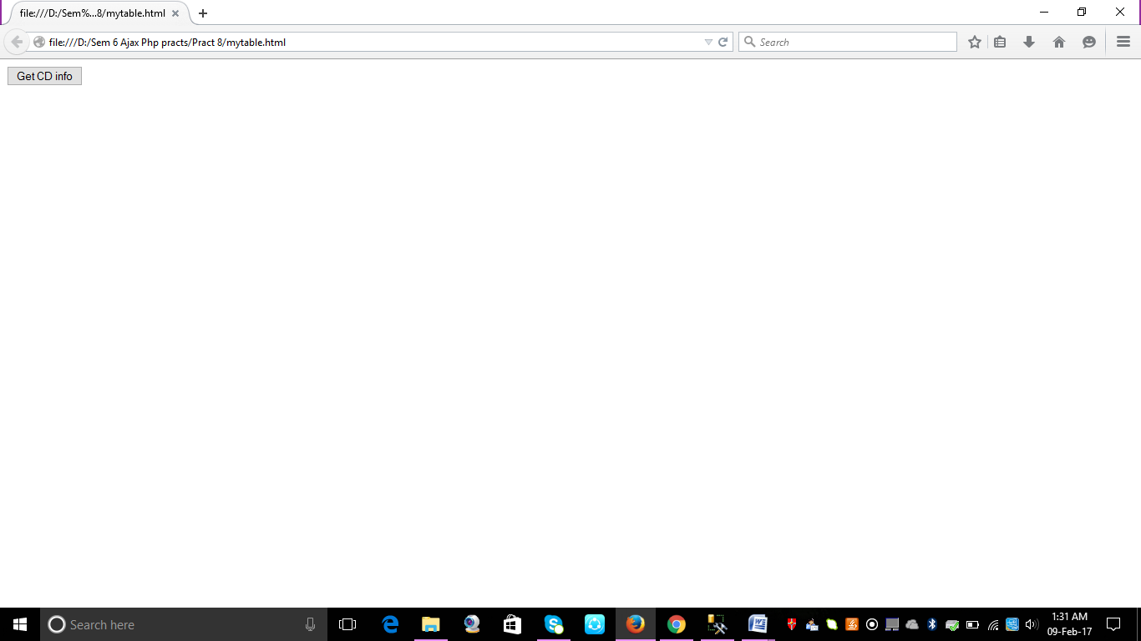

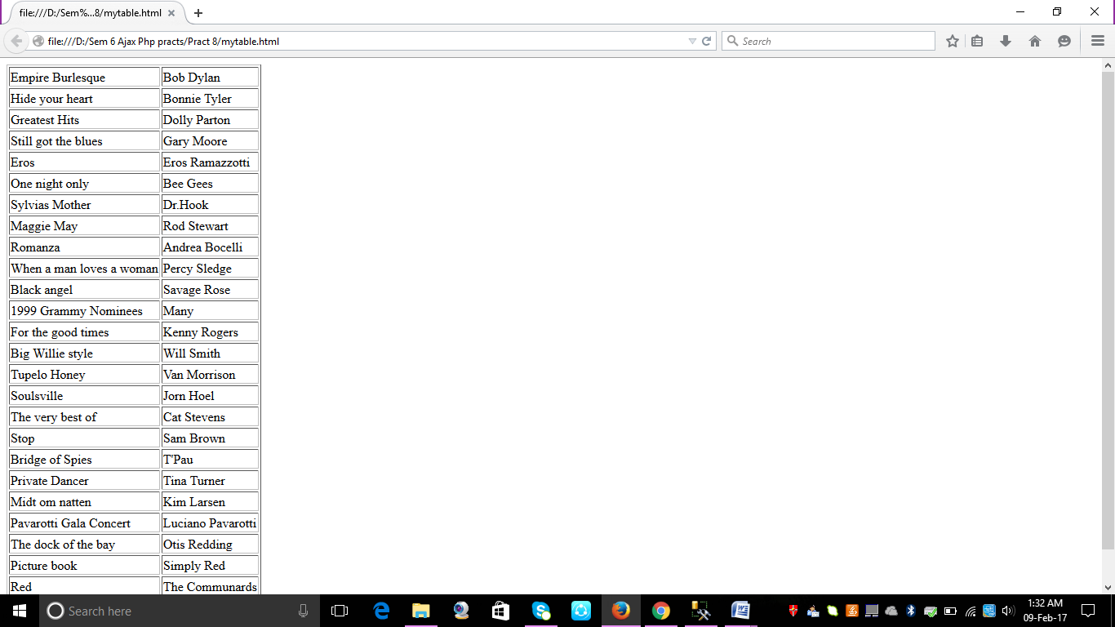

**PRACTICAL NO 9**

**AIM:** To create a html file to display a list box populated with usernames. On selecting a user name, corresponding details should be fetched from the table created in the backend.

**INPUT:**

PHP file

<?php

$q=$_GET["q"];

$con = mysql_connect('localhost', 'root', 'root');

if (!$con)

{

die('Could not connect: ' . mysql_error());

}

mysql_select_db("Username", $con);

$sql="SELECT * FROM user1 WHERE id = '".$q."'";

$result = mysql_query($sql);

echo "<table border='1'>

<tr>

<th>Firstname</th>

<th>Lastname</th>

<th>Age</th>

<th>Hometown</th>

<th>Job</th>

</tr>";

while($row = mysql_fetch_array($result))

{

echo "<tr>";

echo "<td>" . $row['firstname'] . "</td>";

echo "<td>" . $row['lastname'] . "</td>";

echo "<td>" . $row['Age'] . "</td>";

echo "<td>" . $row['HomeTown'] . "</td>";

echo "<td>" . $row['Job'] . "</td>";

echo "</tr>";

}

echo "</table>";

mysql_close($con);

?>

html Code:

<html>

<head>

<script type="text/javascript">

function showUser(str)

{

if (str=="")

{

document.getElementById("txtHint").innerHTML="";

return;

}

if (window.XMLHttpRequest)

{// code for IE7+, Firefox, Chrome, Opera, Safari

xmlhttp=new XMLHttpRequest();

}

else

{// code for IE6, IE5

xmlhttp=new ActiveXObject("Microsoft.XMLHTTP");

}

xmlhttp.onreadystatechange=function()

{

if (xmlhttp.readyState==4 && xmlhttp.status==200)

{

alert(str);

document.getElementById("txtHint").innerHTML=xmlhttp.responseText;

}

}

xmlhttp.open("GET","getuser.php?q="+str,true);

xmlhttp.send();

}

</script>

</head>

<body>

<form>

<select name="users" onchange="showUser(this.value)">

<option value="">Select a person:</option>

<option value="1">ria</option>

<option value="2">sia</option>

<option value="3">samaira</option>

</select>

</form>

**OUTPUT:**

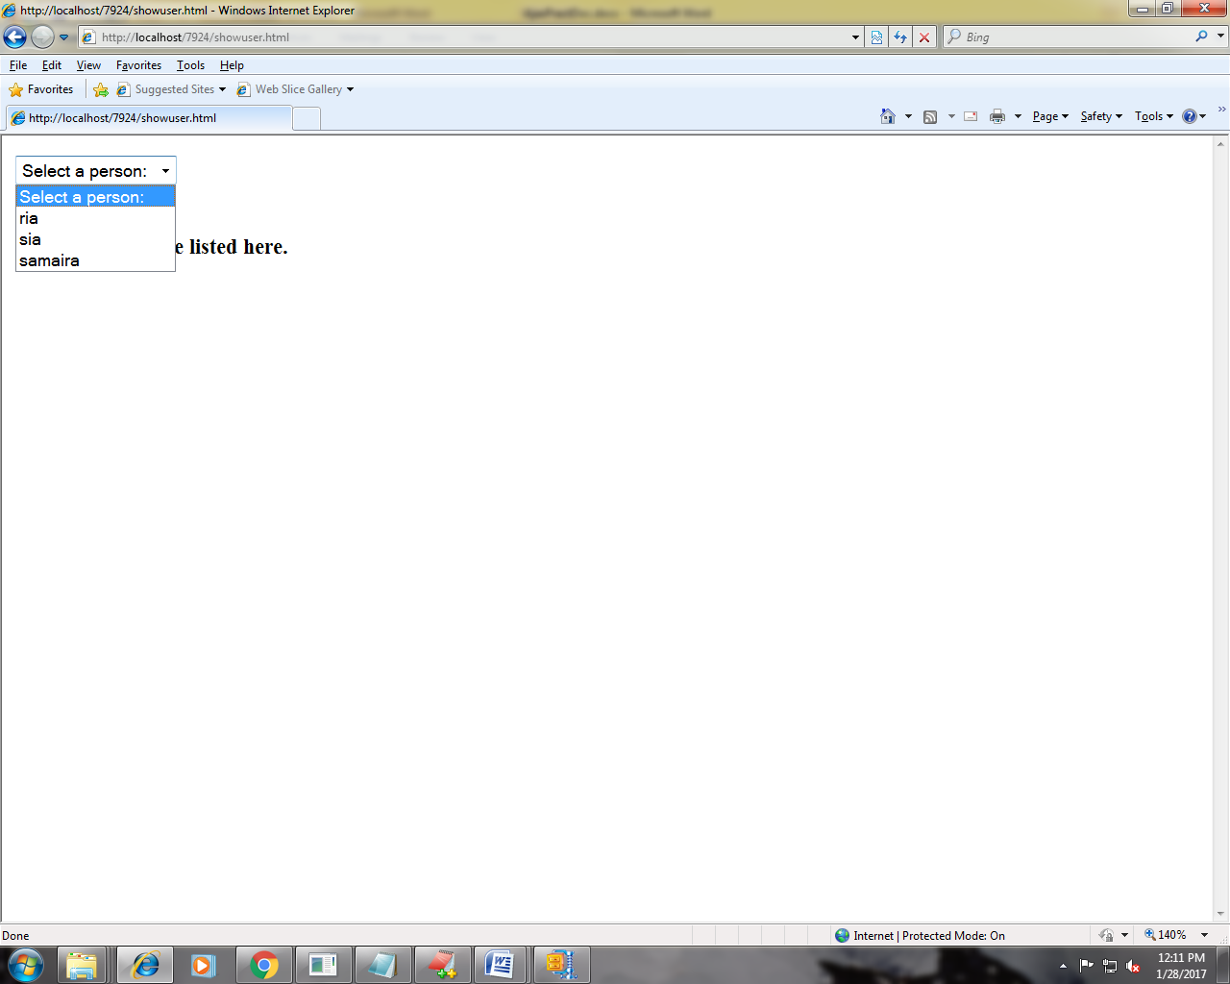

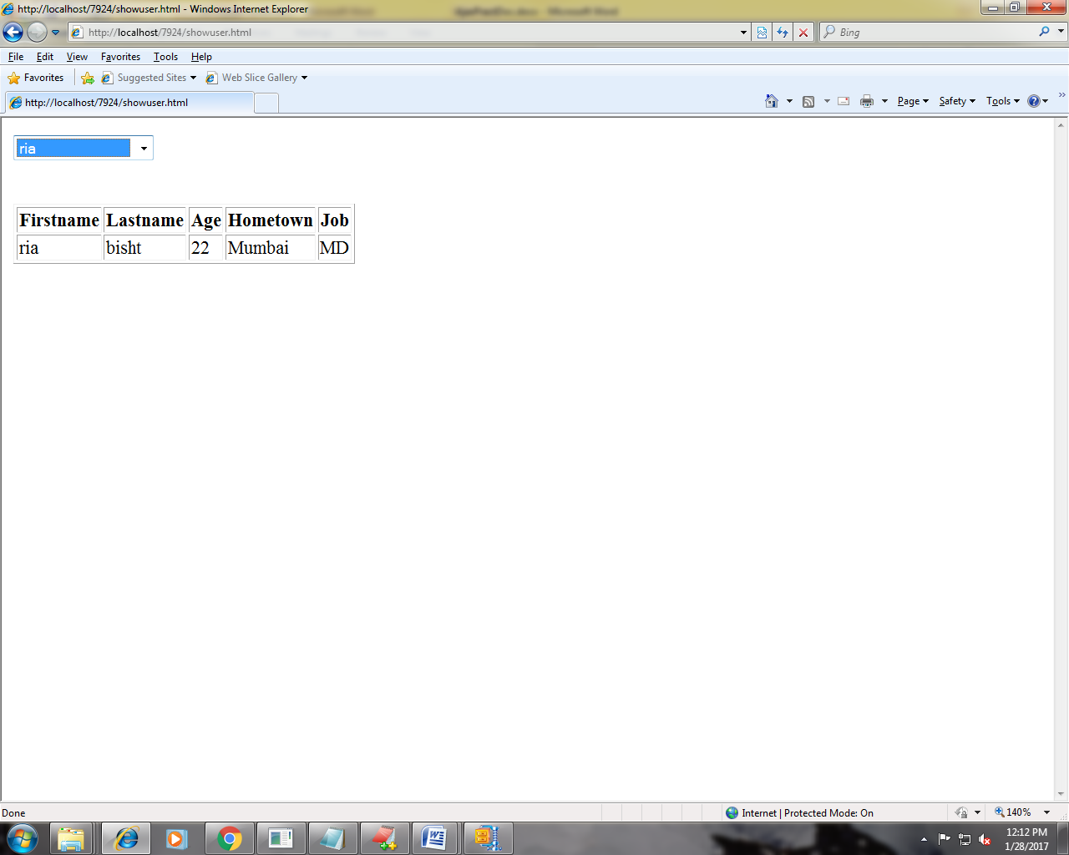

**PRACTICAL NO 1**

**AIM:** To study about basic login form

**INPUT:**

**.aspx**

<%@ Page Language="VB" AutoEventWireup="false" CodeFile="Default.aspx.vb" Inherits="_Default" %>

<!DOCTYPE html PUBLIC "-//W3C//DTD XHTML 1.0 Transitional//EN" "http://www.w3.org/TR/xhtml1/DTD/xhtml1-transitional.dtd">

<html xmlns="http://www.w3.org/1999/xhtml">

<head runat="server">

<title>Untitled Page</title>

<style type="text/css">

.style1

{

}

.style2

{

height: 21px;

}

.style3

{

width: 241px;

}

</style>

</head>

<body>

<p>

&nbsp;</p>

<form id="form1" runat="server">

<div>

<center>

<table style="border-color: #000000; border-style: groove; width: 48%; height: 344px;">

<tr>

<td class="style2" colspan="2">

&nbsp; &nbsp;&nbsp;&nbsp;&nbsp;LOGIN FORM</td>

</tr>

<tr>

<td class="style3">

&nbsp;

USERNAME:</td>

<td>

<asp:TextBox ID="txtUserName" runat="server" Height="28px"></asp:TextBox>

</td>

</tr>

<tr>

<td class="style3">

&nbsp;&nbsp; PASSWORD</td>

<td>

<asp:TextBox ID="txtPassword" runat="server" Height="31px"></asp:TextBox>

</td>

</tr>

<tr>

<td class="style3">

&nbsp;

<asp:Button ID="btnLogin" runat="server" Text="Login" BackColor="Lime"

BorderColor="Black" BorderStyle="Outset" Font-Bold="True" Height="35px"

Width="66px" />

</td>

<td style="border-color: #000000">

&nbsp;

<asp:Button ID="btnReset" runat="server" Text="Reset" BackColor="#FF5050"

BorderColor="Black" Font-Bold="True" Height="36px" Width="67px" />

</td>

</tr>

<tr>

<td class="style1" colspan="2">

<asp:Label ID="lblMessage" runat="server"></asp:Label>

</td>

</tr>

</table>

</center>

</div>

</form>

</body>

</html>

**.aspx.vb**

Imports System.Data.SqlClient

Imports System.Data

Imports System.Web.Configuration

Partial Class _Default

Inherits System.Web.UI.Page

Protected Sub btnLogin_Click(ByVal sender As Object, ByVal e As System.EventArgs) Handles btnLogin.Click

Dim strUsername As String = "Bina"

Dim strPassword As String = "ruia7"

If (txtUserName.Text = strUsername And txtPassword.Text = strPassword) Then

lblMessage.Text = "Login successful"

Response.Redirect("welcome.aspx")

Else

lblMessage.Text = "Login unsuccessful. Please try again!"

Response.Redirect("errorpage.aspx")

End If

End Sub

Protected Sub btnReset_Click(ByVal sender As Object, ByVal e As System.EventArgs) Handles btnReset.Click

txtUserName.Text = ""

txtPassword.Text = ""

End Sub

End Class

**OUTPUT:**

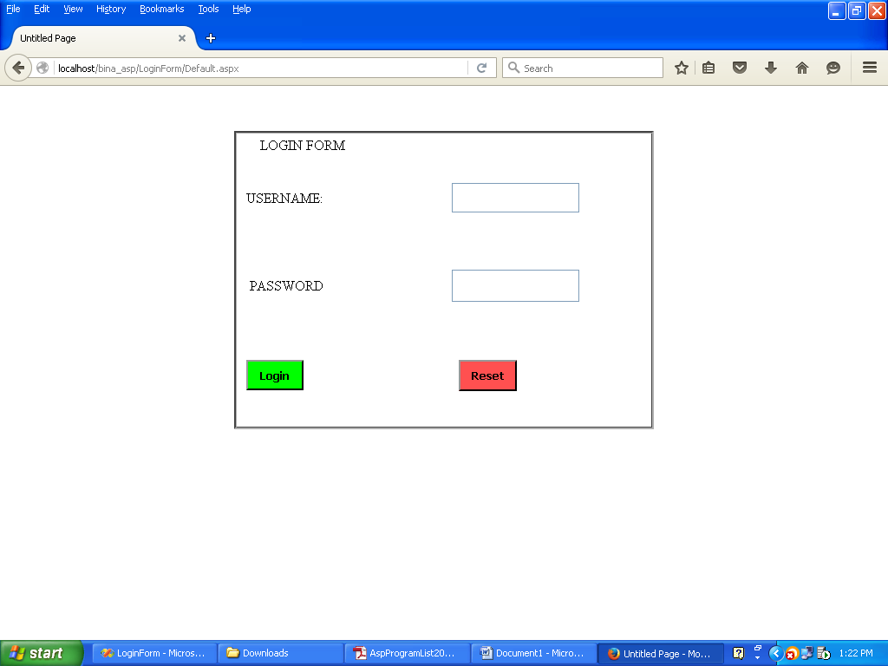

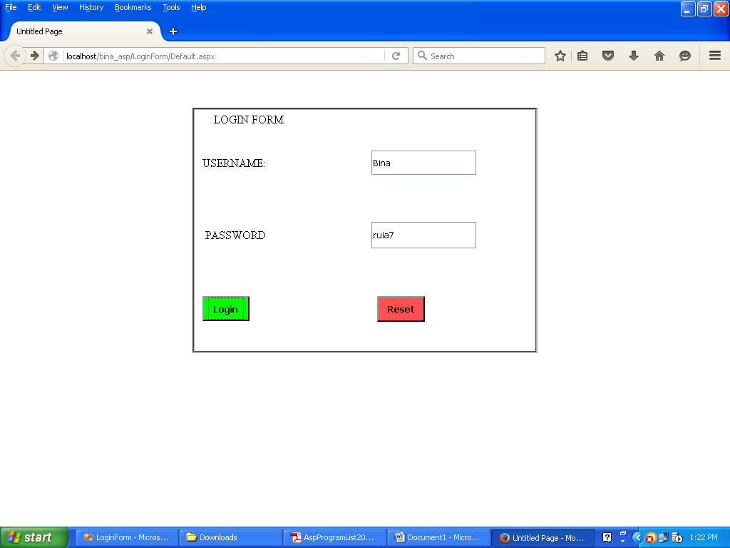

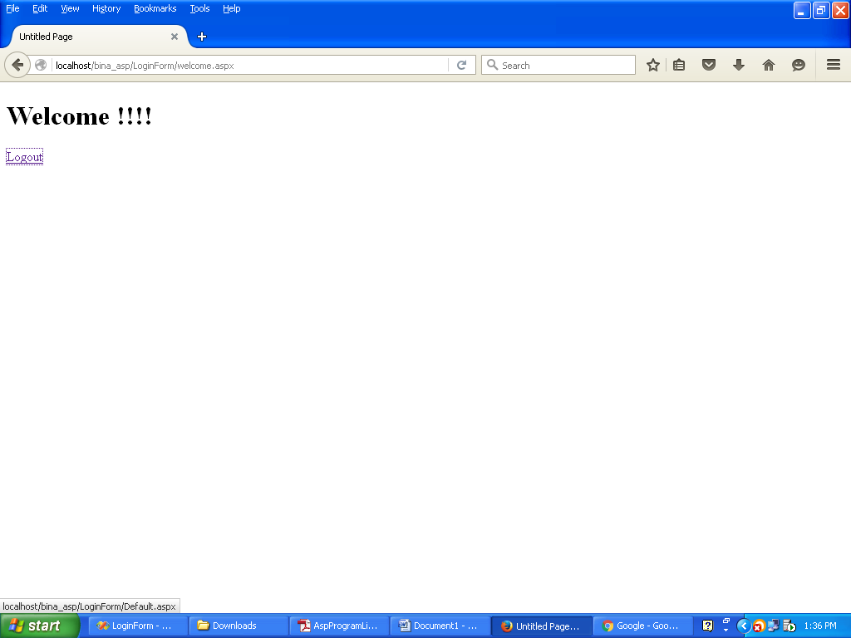

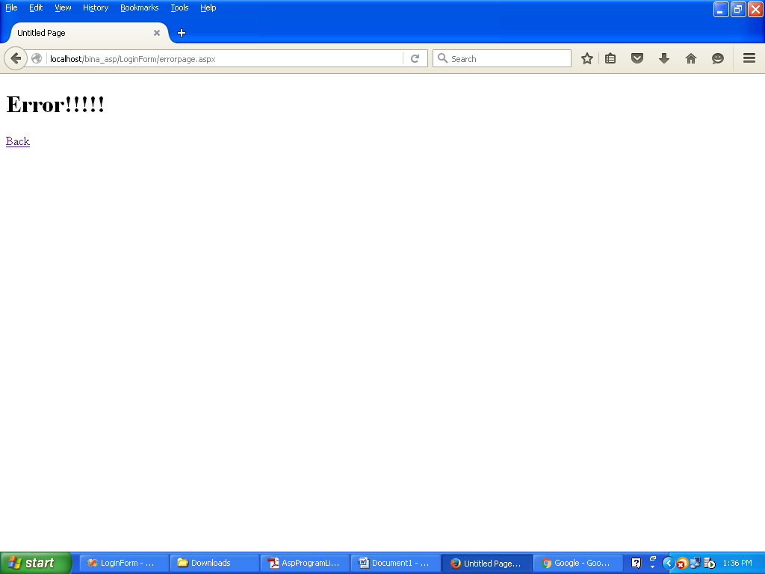

**PRACTICAL NO 2**

**AIM:** To study about Login Form with Database.

**INPUT:**

**AdminLogin.aspx**

<%@ Page Language="VB" AutoEventWireup="false" CodeFile="AdminLogin.aspx.vb" Inherits="AdminLogin" %>

<!DOCTYPE html PUBLIC "-//W3C//DTD XHTML 1.0 Transitional//EN" "http://www.w3.org/TR/xhtml1/DTD/xhtml1-transitional.dtd">

<html xmlns="http://www.w3.org/1999/xhtml">

<head runat="server">

<title>Untitled Page</title>

</head>

<body>

<form id="form1" runat="server">

<div>

<center>

<table style="border-color: #000000; border-style: groove; width: 48%; height: 344px;">

<tr>

<td class="style2" colspan="2">

&nbsp; &nbsp;&nbsp;&nbsp;&nbsp;LOGIN FORM</td>

</tr>

<tr>

<td class="style3">

&nbsp;

USERNAME:</td>

<td>

<asp:TextBox ID="txtUserName" runat="server" Height="28px"></asp:TextBox>

</td>

</tr>

<tr>

<td class="style3">

&nbsp;&nbsp; PASSWORD</td>

<td>

<asp:TextBox ID="txtPassword" runat="server" Height="31px"></asp:TextBox>

</td>

</tr>

<tr>

<td class="style3">

&nbsp;

<asp:Button ID="btnLogin" runat="server" Text="Login" BackColor="Lime"

BorderColor="Black" BorderStyle="Outset" Font-Bold="True" Height="35px"

Width="66px" />

</td>

<td style="border-color: #000000">

&nbsp;

<asp:Button ID="btnReset" runat="server" Text="Reset" BackColor="#FF5050"

BorderColor="Black" Font-Bold="True" Height="36px" Width="67px" />

</td>

</tr>

<tr>

<td class="style1" colspan="2">

<asp:Label ID="lblMessage" runat="server"></asp:Label>

</td>

</tr>

</table>

</center>

</div>

</form>

</body>

</html>

**AdminLogin.aspx.vb**

Imports System.Data

Imports System.Data.SqlClient

Imports System.Web.Configuration

Partial Class AdminLogin

Inherits System.Web.UI.Page

Protected Sub btnLogin_Click(ByVal sender As Object, ByVal e As System.EventArgs) Handles btnLogin.Click

Dim objcon As New SqlConnection(WebConfigurationManager.ConnectionStrings("DBCon").ConnectionString)

objcon.Open()

Dim strquery As String

strquery = "Select * from AdminLogin where username=@u and password=@p"

Dim sqlcmd As New SqlCommand(strquery, objcon)

sqlcmd.Parameters.AddWithValue("@u", txtUserName.Text)

sqlcmd.Parameters.AddWithValue("@p", txtPassword.Text)

Dim objRead As SqlDataReader

objRead = sqlcmd.ExecuteReader()

If objRead.Read Then

Session("user") = txtUserName.Text

Response.Redirect("Home.aspx")

Else

Response.Redirect("errorpage.aspx")

End If

End Sub

Protected Sub btnReset_Click(ByVal sender As Object, ByVal e As System.EventArgs) Handles btnReset.Click

txtUserName.Text = ""

txtPassword.Text = ""

End Sub

End Class

**OUTPUT:**

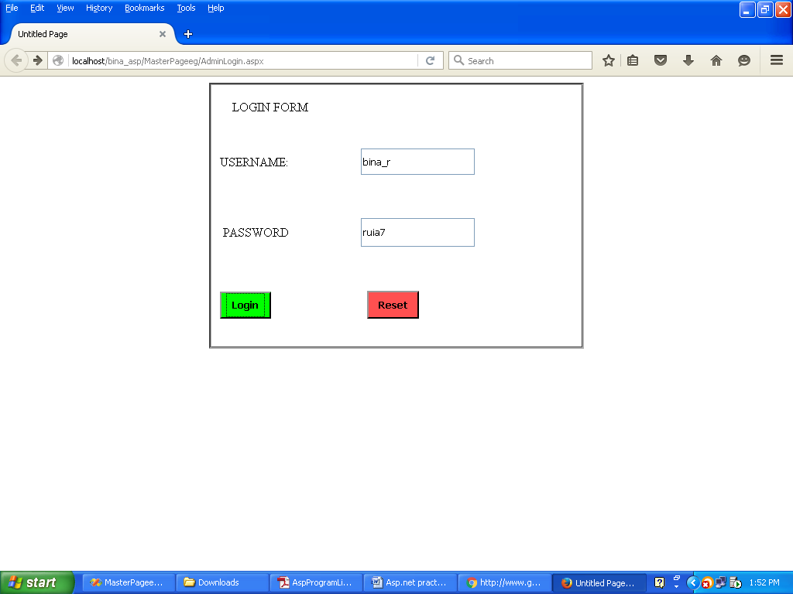





**PRACTICAL NO 3**

**AIM:** To study about designing and implementing master page with website

**INPUT:**

**master.css**

body

{

}

div.main

{

height:1000px;

}

div.logo

{

width:20%;

height:20%;

float:left;

background-color:Fuchsia;

}

div.title

{

width:80%;

height:20%;

float:right;

background-color:#E8DAEF ;

}

div.menu

{

height:5%;

background-color:Gray;

}

ul

{

padding:0;

list-style:none;

background:#f2f2f2;

}

ul li

{

display:inline-block;

position:relative;

line-height:21px;

text-align:left;

top: -21px;

left: 0px;

width: 83px;

}

ul li a

{

display:block;

padding:8px 25px;

color:#333;

text-decoration:none;

}

ul li a:hover

{

color:#fff;

background:blue;

}

ul li ul.dropdown

{

min-width: 125px;

background: #f2f2f2;

display: none;

position: absolute;

z-index: 999;

left: 0;

}

ul li:hover ul.dropdown

{

display:block;

}

ul li ul.dropdown li

{

display:block;

}

div.content

{

height:auto;

}

table.category

{

width:50%;

height:30%;

}

td.cate_title

{

text-align:center;

}

td

{

background-color:#99CCFF;

}

div.tab_cat

{

margin-left:10%;

}

**Masterpage.master**

<%@ Master Language="VB" CodeFile="MasterPage.master.vb" Inherits="MasterPage" %>

<!DOCTYPE html PUBLIC "-//W3C//DTD XHTML 1.0 Transitional//EN" "http://www.w3.org/TR/xhtml1/DTD/xhtml1-transitional.dtd">

<html xmlns="http://www.w3.org/1999/xhtml">

<head runat="server">

<title>Untitled Page</title>

<link href="master.css" rel="stylesheet" type="text/css" />

<asp:ContentPlaceHolder id="head" runat="server">

</asp:ContentPlaceHolder>

</head>

<body>

<form id="form1" runat="server">

<div class="main">

<div class="logo">

<img src="images/Ruia%20R%20Logo.png" style="height: 201px; width: 208px" /></div>

<div class="title"><br />

<center style="font-size: xx-large; border: thick dotted #0000FF">

<h1>LIBRARY</h1>

</center>

</div>

<div class="menu"></div>

<ul>

<li><a href="Home.aspx">HOME</a></li>

<li><a href="Members.aspx">MEMBERS</a>

<ul class="dropdown">

<li><a href="addmember.aspx" style="background-color: #FF9900">ADD MEMBER</a></li>

<li><a href="updatemember.aspx" style="background-color: #FF9900">UPDATE MEMBER</a></li>

<li><a href="deletemember.aspx" style="background-color: #FF9900">DELETE MEMBER</a></li>

</ul>

</li>

<li><a href="Category.aspx">CATEGORY</a>

<ul class="dropdown">

<li><a href="AddCategory.aspx" style="background-color: #FF9900">ADD CATEGORY</a></li>

<li><a href="UpdateCategory.aspx" style="background-color: #FF9900">UPDATE CATEGORY</a></li>

<li><a href="DeleteCategory.aspx" style="background-color: #FF9900">DELETE CATEGORY</a></li>

</ul>

</li>

<li><a href="BookCopies.aspx">BOOK COPIES</a>

<ul class="dropdown">

<li><a href="AddBookCopies.aspx" style="background-color: #FF9900">ADD BOOK COPIES</a></li>

<li><a href="UpdateBookCopies.aspx" style="background-color: #FF9900">UPDATE BOOK COPIES</a></li>

<li><a href="DeleteBookCopies.aspx" style="background-color: #FF9900">DELETE BOOK COPIES</a></li>

</ul>

</li>

<li><a href="Books.aspx">BOOKS</a>

<ul class="dropdown">

<li><a href="addbooks.aspx" style="background-color: #FF9900">ADD BOOKS</a></li>

<li><a href="updatebook.aspx" style="background-color: #FF9900">UPDATE BOOKS</a></li>

<li><a href="deletebook.aspx" style="background-color: #FF9900">DELETE BOOKS</a></li>

</ul>

</li>

<li><a href="Operations.aspx">OPERATIONS</a>

<ul class="dropdown">

<li><a href="IssueBook.aspx" style="background-color: #FF9900">ISSUE BOOK</a></li>

<li><a href="ReturnBook.aspx" style="background-color: #FF9900">RETURN BOOK</a></li>

<li><a href="fine.aspx" style="background-color: #FF9900">PAY FINE</a></li>

</ul>

</li>

<li><a href="Reports.aspx">REPORTS</a>

<ul class="dropdown">

<li><a href="MemberReport.aspx" style="background-color: #FF9900">MEMBER REPORT</a></li>

<li><a href="BookReport.aspx" style="background-color: #FF9900">BOOK REPORT</a></li>

<li><a href="FineReport.aspx" style="background-color: #FF9900">FINE REPORT</a></li>

</ul>

</li>

<li><a href="Aboutus.aspx">ABOUT US</a></li>

<li><a href="Contact.aspx">CONTACT</a></li>

</ul>

<div>

<asp:ContentPlaceHolder ID="ContentPlaceHolder1" runat="server">

</asp:ContentPlaceHolder>

</div>

</form>

</body>

</html>

<%@ Page Language="VB" MasterPageFile="~/MasterPage.master" AutoEventWireup="false" CodeFile="Home.aspx.vb" Inherits="Home" title="Untitled Page" %>

<asp:Content ID="Content1" ContentPlaceHolderID="head" Runat="Server">

</asp:Content>

<asp:Content ID="Content2" ContentPlaceHolderID="ContentPlaceHolder1" Runat="Server">

</asp:Content>

**Masterpage.master.vb**

Partial Class Home

Inherits System.Web.UI.Page

Protected Sub Page_Load(ByVal sender As Object, ByVal e As System.EventArgs) Handles Me.Load

If Session("user") = "" Then

Response.Redirect("errorpage.aspx?msg=" & "Please Login")

End If

End Sub

End Class

**OUTPUT:**

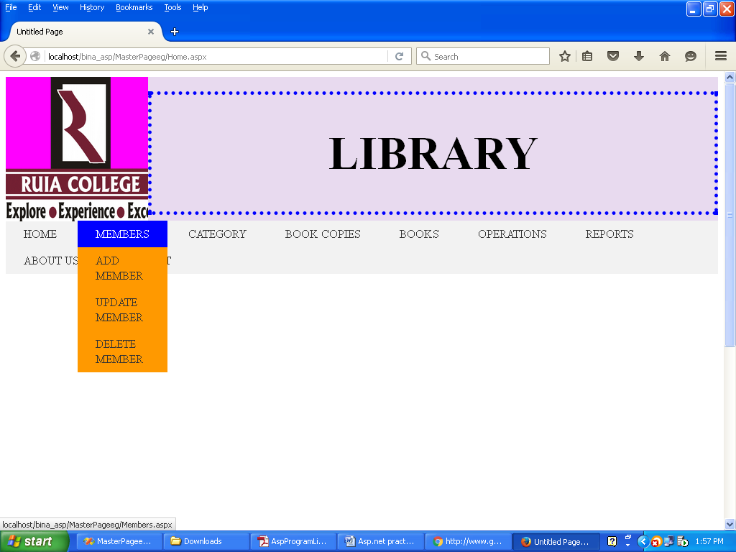

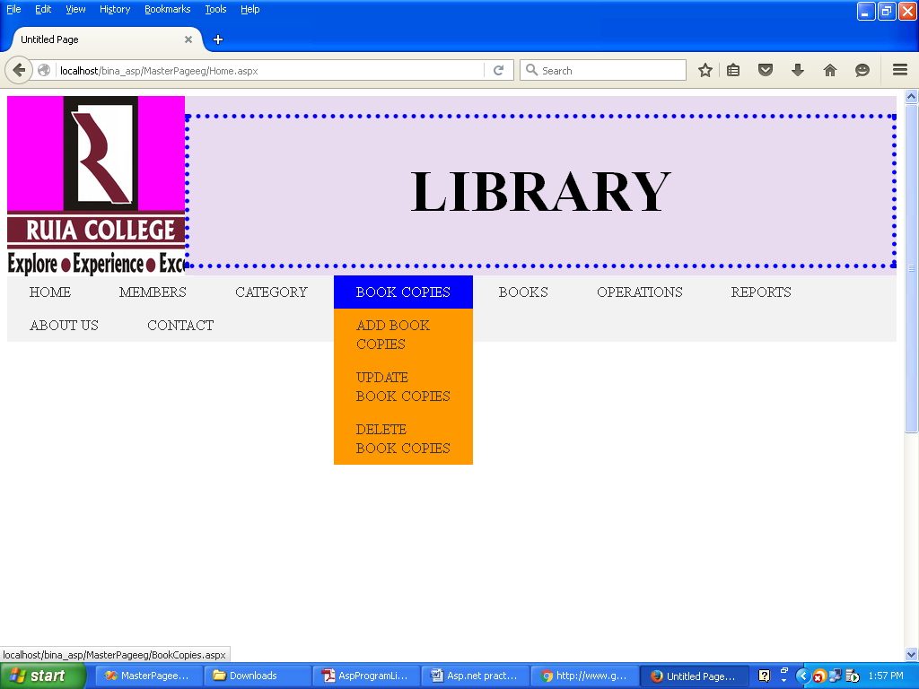

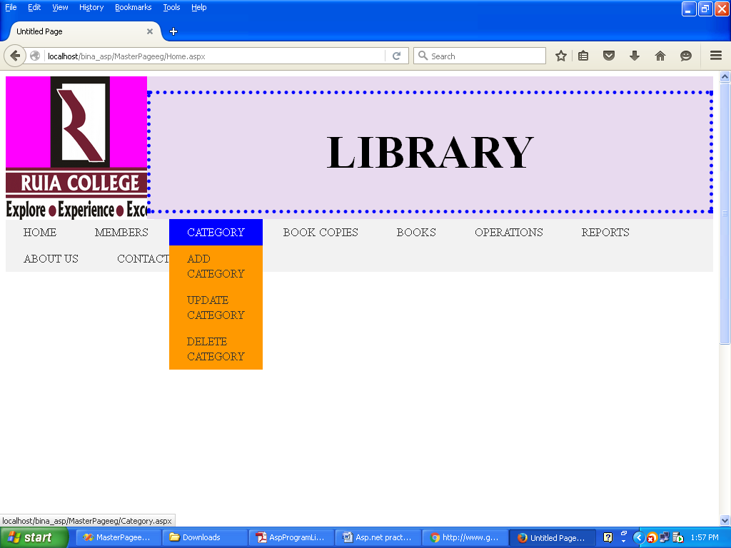

**PRACTICAL NO 4**

**AIM:** To study about database connectivity

**INPUT:**

**AddCategory.aspx**

<%@ Page Language="VB" MasterPageFile="~/MasterPage.master" AutoEventWireup="false" CodeFile="AddCategory.aspx.vb" Inherits="AddCategory" title="AddCategory" %>

<asp:Content ID="Content1" ContentPlaceHolderID="head" Runat="Server">

<style type="text/css">

.style1

{

height: 68px;

}

.style2

{

height: 24px;

}

.style3

{

height: 68px;

width: 456px;

}

.style4

{

width: 456px;

height: 87px;

}

.style5

{

height: 104px;

width: 456px;

}

.style6

{

height: 104px;

}

.style7

{

height: 87px;

}

</style>

</asp:Content>

<asp:Content ID="Content2" ContentPlaceHolderID="ContentPlaceHolder1" Runat="Server">

<div>

<table style="width:100%;">

<tr>

<td class="style2" colspan="2">

&nbsp;&nbsp;&nbsp;&nbsp;&nbsp;&nbsp;&nbsp;&nbsp;&nbsp;&nbsp;&nbsp;&nbsp;&nbsp;&nbsp;&nbsp;&nbsp;&nbsp;&nbsp;&nbsp;&nbsp;&nbsp;&nbsp;&nbsp;&nbsp;&nbsp;&nbsp;&nbsp;&nbsp;&nbsp;&nbsp;&nbsp;&nbsp;&nbsp;&nbsp;&nbsp;&nbsp;&nbsp;&nbsp;&nbsp;&nbsp;&nbsp;&nbsp;&nbsp;&nbsp;&nbsp;&nbsp;&nbsp;&nbsp;&nbsp;&nbsp;&nbsp;&nbsp;&nbsp;&nbsp;&nbsp;&nbsp;&nbsp;&nbsp;&nbsp;&nbsp;&nbsp;&nbsp;&nbsp;&nbsp;&nbsp;&nbsp;&nbsp;&nbsp;&nbsp;&nbsp;&nbsp;&nbsp;&nbsp;&nbsp;&nbsp;&nbsp;&nbsp;&nbsp;&nbsp;&nbsp;&nbsp;&nbsp;&nbsp;&nbsp;&nbsp;&nbsp;&nbsp;&nbsp;&nbsp;&nbsp;&nbsp;&nbsp;&nbsp;&nbsp;&nbsp;&nbsp;&nbsp;

ADD CATEGORY</td>

</tr>

<tr>

<td class="style3">

CATEGORY ID:</td>

<td class="style1">

<asp:TextBox ID="txtcatid" runat="server"></asp:TextBox>

</td>

</tr>

<tr>

<td class="style5">

CATEGORY NAME:</td>

<td class="style6">

<asp:TextBox ID="txtcatname" runat="server"></asp:TextBox>

</td>

</tr>

<tr>

<td class="style4">

<asp:Button ID="btnaddCat" runat="server" Text="Add Category" />

</td>

<td class="style7">

<asp:Button ID="btncancel" runat="server" Text="Cancel" />

</td>

</tr>

<tr>

<td class="style4">

<asp:Label ID="lblMsg" runat="server"></asp:Label>

</td>

<td class="style7">

&nbsp;</td>

</tr>

</table>

</div>

</asp:Content>

**AddCategory.aspx.vb**

Imports System.Data

Imports System.Data.SqlClient

Imports System.Web.Configuration

Partial Class AddCategory

Inherits System.Web.UI.Page

Protected Sub Page_Load(ByVal sender As Object, ByVal e As System.EventArgs) Handles Me.Load

End Sub

Protected Sub btnaddCat_Click(ByVal sender As Object, ByVal e As System.EventArgs) Handles addCat.Click

Dim objcon As New SqlConnection(WebConfigurationManager.ConnectionStrings("DBCon").ConnectionString)

Dim strquery As String = "insert into Category values(@catid,@catname)"

Dim objcmd As New SqlCommand(strquery, objcon)

objcmd.Parameters.AddWithValue("@catid", txtcatid.Text)

objcmd.Parameters.AddWithValue("@catname", txtcatname.Text)

Try

objcon.Open()

Dim intflag As Integer = objcmd.ExecuteNonQuery()

If intflag > 0 Then

lblMsg.Text = "<b>" & "Record Inserted successfully" & "</b>"

txtcatid.Text = ""

txtcatname.Text = ""

End If

Catch ex As Exception

Throw ex

Finally

objcon.Close()

End Try

End Sub

End Class

**OUTPUT:**

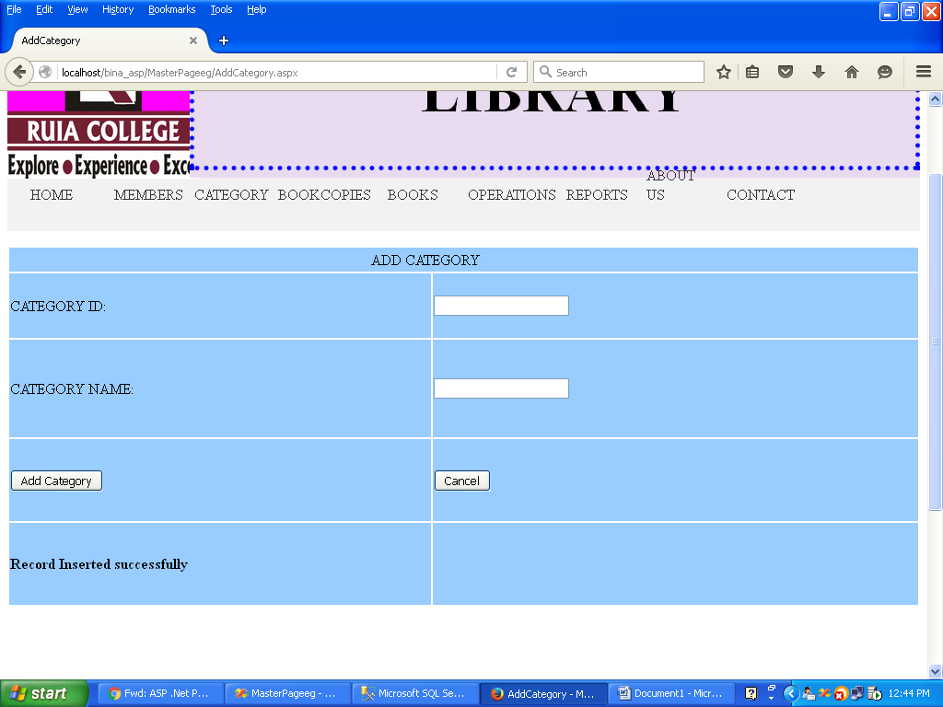

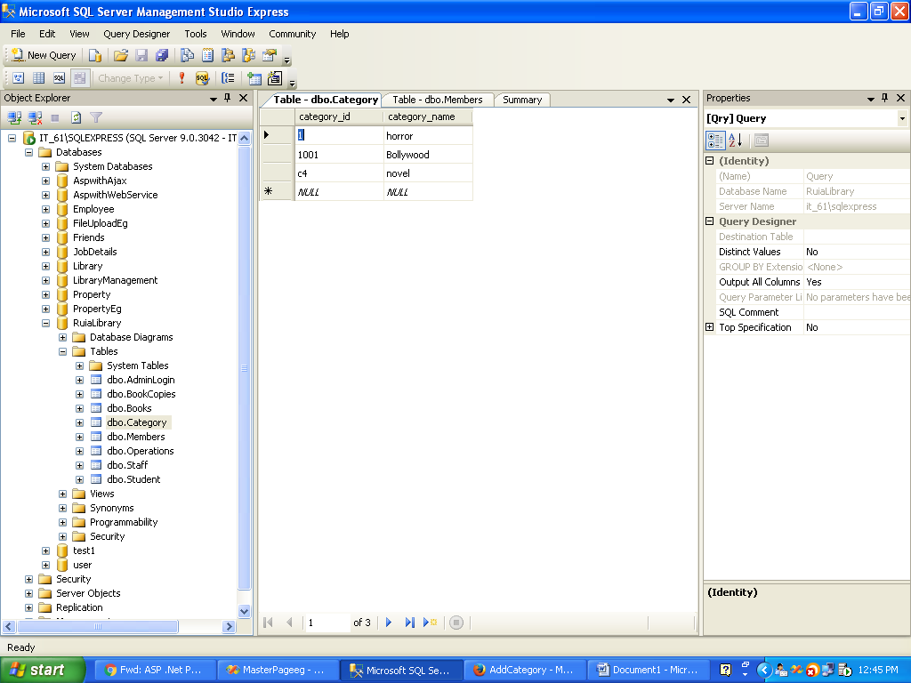

**INPUT:**

**RuiaLibrary class**

Imports Microsoft.VisualBasic

Namespace RuiaLibraryClass

Public Class RuiaLibrary

End Class

Public MustInherit Class Categories

Private m_catid As String

Private m_catname As String

Public Property CatId() As String

Get

Return m_catid

End Get

Set(ByVal value As String)

m_catid = value

End Set

End Property

Public Property CatName() As String

Get

Return m_catname

End Get

Set(ByVal value As String)

m_catname = value

End Set

End Property

End Class

Public MustInherit Class Books

Inherits Categories

Private m_bookid As String

Private m_isbn As String

Private m_bookname As String

Private m_auth1 As String

Private m_auth2 As String

Private m_auth3 As String

Private m_publication As String

Private m_edition As String

Private m_price As String

Private m_dicprice As String

Public Property BookId() As String

Get

Return m_bookid

End Get

Set(ByVal value As String)

m_bookid = value

End Set

End Property

Public Property Isbn() As String

Get

Return m_isbn

End Get

Set(ByVal value As String)

m_isbn = value

End Set

End Property

Public Property Bookname() As String

Get

Return m_bookname

End Get

Set(ByVal value As String)

m_bookname = value

End Set

End Property

Public Property Author1() As String

Get

Return m_auth1

End Get

Set(ByVal value As String)

m_auth1 = value

End Set

End Property

Public Property Author2() As String

Get

Return m_auth2

End Get

Set(ByVal value As String)

m_auth2 = value

End Set

End Property

Public Property Author3() As String

Get

Return m_auth3

End Get

Set(ByVal value As String)

m_auth3 = value

End Set

End Property

Public Property Publication() As String

Get

Return m_publication

End Get

Set(ByVal value As String)

m_publication = value

End Set

End Property

Public Property Edition() As String

Get

Return m_edition

End Get

Set(ByVal value As String)

m_edition = value

End Set

End Property

Public Property Price() As String

Get

Return m_price

End Get

Set(ByVal value As String)

m_price = value

End Set

End Property

Public Property Discount() As String

Get

Return m_dicprice

End Get

Set(ByVal value As String)

m_dicprice = value

End Set

End Property

End Class

Public Class BookCopies

Inherits Books

Private m_no_of_copies As String

Private m_availability As String

Public Property NoOfCopies() As String

Get

Return m_no_of_copies

End Get

Set(ByVal value As String)

m_no_of_copies = value

End Set

End Property

Public Property Avail() As String

Get

Return m_availability

End Get

Set(ByVal value As String)

m_availability = value

End Set

End Property

End Class

End Namespace

**InsertOperation class**

Imports Microsoft.VisualBasic

Imports System.Data.SqlClient

Imports System.Data

Imports RuiaLibraryClass

Public Class InsertOperation

Public Shared Function Addbooks(ByVal Books As BookCopies) As Integer

Dim objConn As SqlConnection = Dbconnection.GetConnection

Dim strQuery As String = "insert into Book values(@Bookid,@catid,@Bookname,@auth1,@auth2,@auth3,@pub,,@price,@discprice,@isbn,@edi)"

Dim objcmd As New SqlCommand(strQuery, objConn)

objcmd.Parameters.AddWithValue("@Bookid", Books.Bookid)

objcmd.Parameters.AddWithValue("@Bookname", Books.Bookname)

objcmd.Parameters.AddWithValue("@catid", Books.CatID)

objcmd.Parameters.AddWithValue("@price", Books.Price)

objcmd.Parameters.AddWithValue("@discprice", Books.Discount)

objcmd.Parameters.AddWithValue("@pub", Books.Publication)

objcmd.Parameters.AddWithValue("@auth1", Books.Author1)

objcmd.Parameters.AddWithValue("@auth2", Books.Author2)

objcmd.Parameters.AddWithValue("@auth3", Books.Author3)

objcmd.Parameters.AddWithValue("@edi", Books.Edition)

objcmd.Parameters.AddWithValue("@isbn", Books.Isbn)

Try

objConn.Open()

Dim intFlag As Integer = objcmd.ExecuteNonQuery

Return intFlag

Catch ex As Exception

Throw ex

Finally

objConn.Close()

End Try

End Function

End Class

**AddBook.aspx**

<%@ Page Language="VB" MasterPageFile="~/MasterPage.master" AutoEventWireup="false" CodeFile="addbooks.aspx.vb" Inherits="addbooks" title="AddBooks" %>

<asp:Content ID="Content1" ContentPlaceHolderID="head" Runat="Server">

<style type="text/css">

.style1

{

width: 326px;

}

</style>

</asp:Content>

<asp:Content ID="Content2" ContentPlaceHolderID="ContentPlaceHolder1" Runat="Server">

<table style="width:100%;">

<tr>

<td colspan="2">

&nbsp;&nbsp;&nbsp;&nbsp;&nbsp;&nbsp;&nbsp;&nbsp;&nbsp;&nbsp;&nbsp;&nbsp;&nbsp;&nbsp;&nbsp;&nbsp;&nbsp;&nbsp;&nbsp;&nbsp;&nbsp;&nbsp;&nbsp;&nbsp;&nbsp;&nbsp;&nbsp;&nbsp;&nbsp;&nbsp;&nbsp;&nbsp;&nbsp;&nbsp;&nbsp;&nbsp;&nbsp;&nbsp;&nbsp;&nbsp;&nbsp;&nbsp;&nbsp;&nbsp;&nbsp;&nbsp;&nbsp;&nbsp;&nbsp;&nbsp;&nbsp;&nbsp;&nbsp;&nbsp;&nbsp;&nbsp;&nbsp;&nbsp;&nbsp;&nbsp;&nbsp;&nbsp;&nbsp;&nbsp;&nbsp;&nbsp;&nbsp;&nbsp;&nbsp;&nbsp;&nbsp;&nbsp;&nbsp;&nbsp;&nbsp;&nbsp;&nbsp;&nbsp;&nbsp;&nbsp;&nbsp;&nbsp;

Add Books&nbsp;</td>

</tr>

<tr>

<td class="style1">

Book Id</td>

<td>

<asp:TextBox ID="txtAddBookId" runat="server"></asp:TextBox>

</td>

</tr>

<tr>

<td class="style1">

Book Category</td>

<td>

<asp:DropDownList ID="ddlCategory" runat="server" AutoPostBack="True">

</asp:DropDownList>

<asp:Label ID="lblcat" runat="server"></asp:Label>

</td>

</tr>

<tr>

<td class="style1">

ISBN No:</td>

<td>

<asp:TextBox ID="txtAddISBNo" runat="server"></asp:TextBox>

</td>

</tr>

<tr>

<td class="style1">

Book Name:</td>

<td>

<asp:TextBox ID="txtAddBookName" runat="server"></asp:TextBox>

</td>

</tr>

<tr>

<td class="style1">

Author 1</td>

<td>

<asp:TextBox ID="txtAddAuthor1" runat="server"></asp:TextBox>

</td>

</tr>

<tr>

<td class="style1">

Author 2</td>

<td>

<asp:TextBox ID="txtAddAuthor2" runat="server"></asp:TextBox>

</td>

</tr>

<tr>

<td class="style1">

Author 3</td>

<td>

<asp:TextBox ID="txtAddAuthor3" runat="server"></asp:TextBox>

</td>

</tr>

<tr>

<td class="style1">

Publication:</td>

<td>

<asp:TextBox ID="txtAddPublication" runat="server"></asp:TextBox>

</td>

</tr>

<tr>

<td class="style1">

Edition</td>

<td>

<asp:TextBox ID="txtAddEdition" runat="server"></asp:TextBox>

</td>

</tr>

<tr>

<td class="style1">

Book price:</td>

<td>

<asp:TextBox ID="txtAddBookPrice" runat="server"></asp:TextBox>

</td>

</tr>

<tr>

<td class="style1">

Discount Price:</td>

<td>

<asp:TextBox ID="txtAddDiscountPrice" runat="server"></asp:TextBox>

</td>

</tr>

<tr>

<td class="style1">

<asp:Button ID="btnAddBook" runat="server" Text="Add Book" Width="82px" />

</td>

<td>

<asp:Label ID="lblsucces" runat="server"></asp:Label>

</td>

</tr>

</table>

</asp:Content>

**AddBooks.aspx.vb**

Imports System.Data.SqlClient

Imports System.Data

Imports RuiaLibraryClass

Partial Class addbooks

Inherits System.Web.UI.Page

Dim objcon As SqlConnection = DBConnection.GetConnection

Protected Sub Page_Load(ByVal sender As Object, ByVal e As System.EventArgs) Handles Me.Load

If Me.IsPostBack = False Then

Dim strquery As String = "Select * from Category"

Dim objcmd1 As New SqlCommand(strquery, objcon)

Try

objcon.Open()

Dim objread As SqlDataReader = objcmd1.ExecuteReader()

While objread.Read()

DropDownList1.Items.Add(objread(1))

End While

Catch ex As Exception

Throw ex

End Try

End If

End Sub

Protected Sub ddlCategory _SelectedIndexChanged(ByVal sender As Object, ByVal e As System.EventArgs) Handles DropDownList1.SelectedIndexChanged

Dim strquery As String = "Select category_id from Category where category_name=@catname"

Dim objcmd2 As New SqlCommand(strquery, objcon)

objcmd2.Parameters.AddWithValue("@catname", DropDownList1.SelectedItem.Text)

'lblmsg.Text = "hello"

Try

objcon.Open()

Dim objread As SqlDataReader = objcmd2.ExecuteReader()

While objread.Read()

lblcat.Text = objread(0).ToString

End While

Catch ex As Exception

End Try

End Sub

Protected Sub btnAddBook_Click(ByVal sender As Object, ByVal e As System.EventArgs) Handles btnAddBook.Click

Dim objbooks As New BookCopies

objbooks.BookId = Val(txtAddBookId.Text)

objbooks.CatId = lblcat.Text

objbooks.Bookname = Val(txtAddBookName.Text)

objbooks.Author1 = Val(txtAddAuthor1.Text)

objbooks.Author2 = Val(txtAddAuthor2.Text)

objbooks.Author3 = Val(txtAddAuthor3.Text)

objbooks.Publication = Val(txtAddPublication.Text)

objbooks.Price = Val(txtAddBookPrice.Text)

objbooks.Discount = Val(txtAddDiscountPrice.Text)

objbooks.Isbn = Val(txtAddISBNo.Text)

objbooks.Edition = Val(txtAddEdition.Text)

Try

objcon.Open()

Dim intflag As Integer = InsertOperation.Addbooks(objbooks)

If intflag > 0 Then

lblsucces.Text = "Book ADDED sUCCESSFULLY!"

objcon.Close()

End If

Catch ex As Exception

ex.Message.ToString()

End Try

End Sub

End Class

**INPUT:**

**AddMember.aspx**

<%@ Page Language="VB" MasterPageFile="~/MasterPage.master" AutoEventWireup="false" CodeFile="addmember.aspx.vb" Inherits="addmember" title="AddMember" %>

<asp:Content ID="Content1" ContentPlaceHolderID="head" Runat="Server">

</asp:Content>

<asp:Content ID="Content2" ContentPlaceHolderID="ContentPlaceHolder1" Runat="Server">

<table style="width: 453px; height: 371px">

<tr>

<td>

Member Id:

</td>

<td>

<asp:TextBox ID="txtMemberId" runat="server"></asp:TextBox>

</td></tr>

<tr><td>

Member Name:

</td>

<td>

<asp:TextBox ID="txtMemberName" runat="server"></asp:TextBox>

</td></tr>

<tr><td>

Address

</td>

<td>

<asp:TextBox ID="txtAddress1" runat="server"></asp:TextBox>

</td>

<td>

<asp:TextBox ID="txtAddress2" runat="server"></asp:TextBox>

</td></tr>

<tr><td>

Suburb

</td>

<td>

<asp:TextBox ID="txtSuburb" runat="server"></asp:TextBox>

</td></tr>

<tr><td>

City

</td>

<td>

<asp:TextBox ID="txtCity" runat="server"></asp:TextBox>

</td></tr>

<tr> <td>

Pincode

</td>

<td>

<asp:TextBox ID="txtPincode" runat="server"></asp:TextBox>

</td></tr>

<tr><td>

Contact:

</td>

<td>

<asp:TextBox ID="txtMobile" runat="server"></asp:TextBox>

</td>

<td>

<asp:TextBox ID="txtLandline" runat="server"></asp:TextBox>

</td></tr>

<tr><td>

Member_type:

</td>

<td>

<asp:TextBox ID="txtMemberType" runat="server"></asp:TextBox>

</td></tr>

<tr><td>

Parent_Contact:

</td>

<td>

<asp:TextBox ID="txtParentContact" runat="server"></asp:TextBox>

</td></tr>

</table><br />

<asp:Button ID="btnAddMember" runat="server" Text="Add Member" />

<br />

<br />

<asp:Label ID="lblMsg" runat="server"></asp:Label>

</asp:Content>

**AddMember.aspx.vb**

Imports System.Data

Imports System.Data.SqlClient

Imports System.Web.Configuration

Partial Class addmember

Inherits System.Web.UI.Page

Protected Sub btnAddMember_Click(ByVal sender As Object, ByVal e As System.EventArgs) Handles btnAddMember.Click

Dim objcon As New SqlConnection(WebConfigurationManager.ConnectionStrings("DBCon").ConnectionString)

Dim strquery As String = "insert into Members values(@member_id,@member_name,@address1,@address2,@suburb,@city,@pincode,@mobile,@landline,@member_type,@parent_contact)"

Dim objcmd As New SqlCommand(strquery, objcon)

Try

objcon.Open()

objcmd.Parameters.AddWithValue("@member_id", txtMemberId.Text)

objcmd.Parameters.AddWithValue("@member_name", txtMemberName.Text)

objcmd.Parameters.AddWithValue("@address1", txtAddress1.Text)

objcmd.Parameters.AddWithValue("@address2", txtAddress2.Text)

objcmd.Parameters.AddWithValue("@suburb", txtMemberId.Text)

objcmd.Parameters.AddWithValue("@city", txtCity.Text)

objcmd.Parameters.AddWithValue("@pincode", txtMemberId.Text)

objcmd.Parameters.AddWithValue("@mobile", txtMobile.Text)

objcmd.Parameters.AddWithValue("@landline", txtLandline.Text)

objcmd.Parameters.AddWithValue("@member_type", txtMemberType.Text)

objcmd.Parameters.AddWithValue("@parent_contact", txtParentContact.Text)

Dim intflag As Integer = objcmd.ExecuteNonQuery()

If intflag > 0 Then

lblmsg.Text = "<b>" & "Record Inserted successfully" & "</b>"

End If

Catch ex As Exception

Throw ex

Finally

objcon.Close()

End Try

End Sub

End Class

**OUTPUT:**

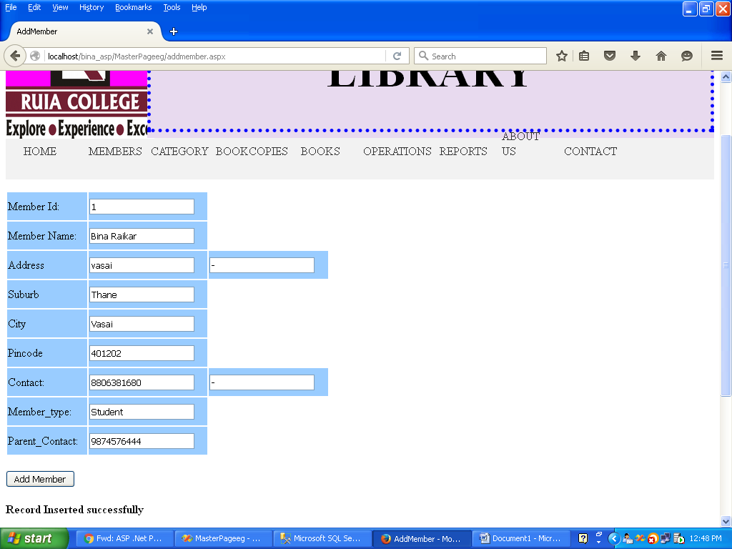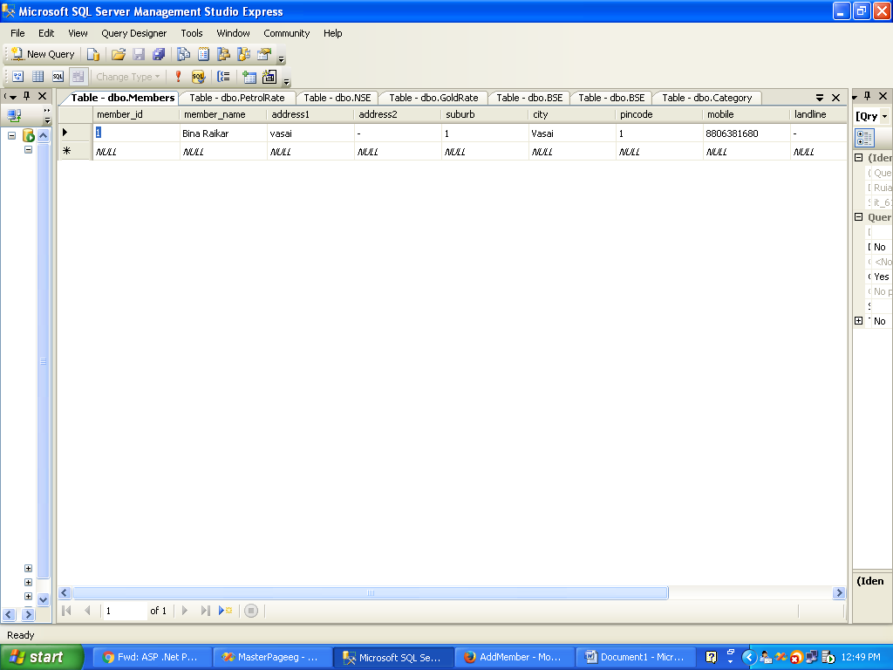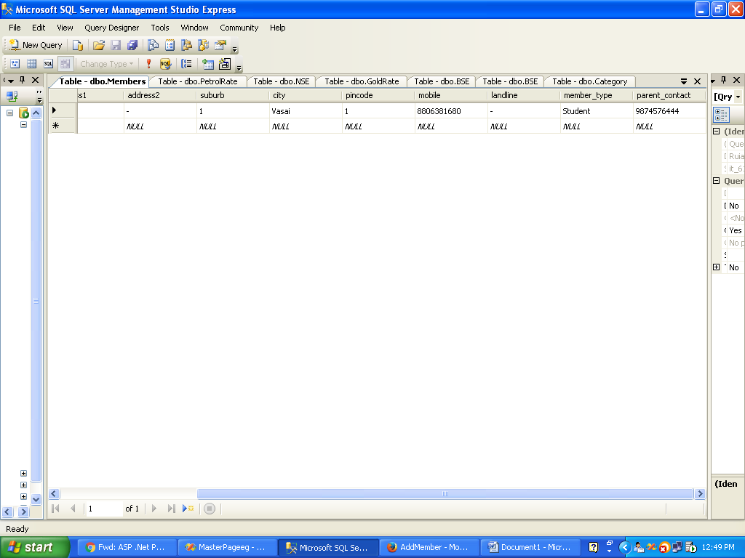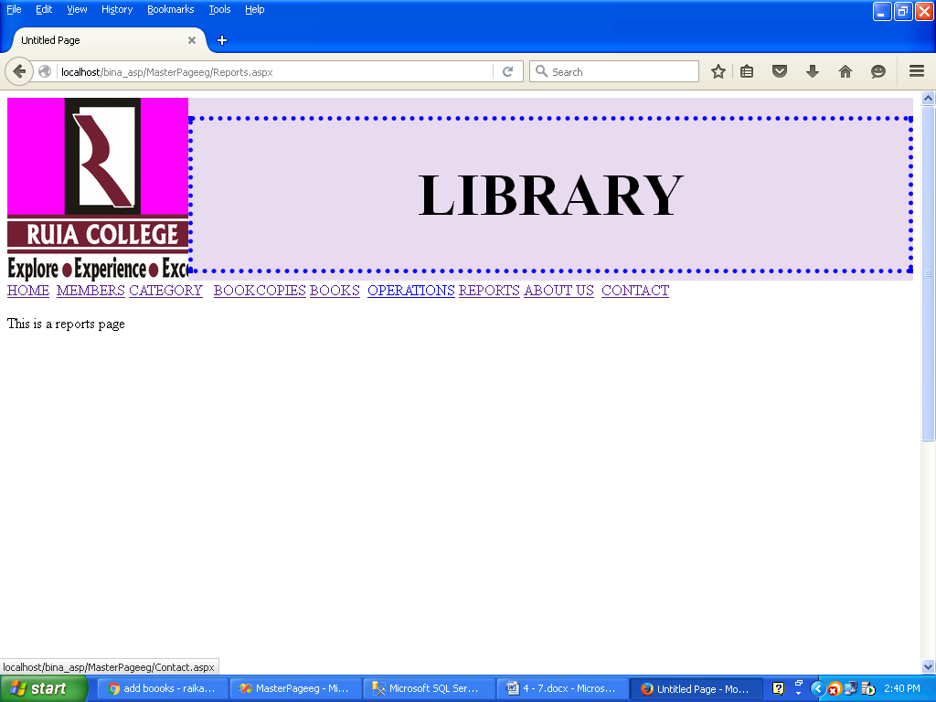 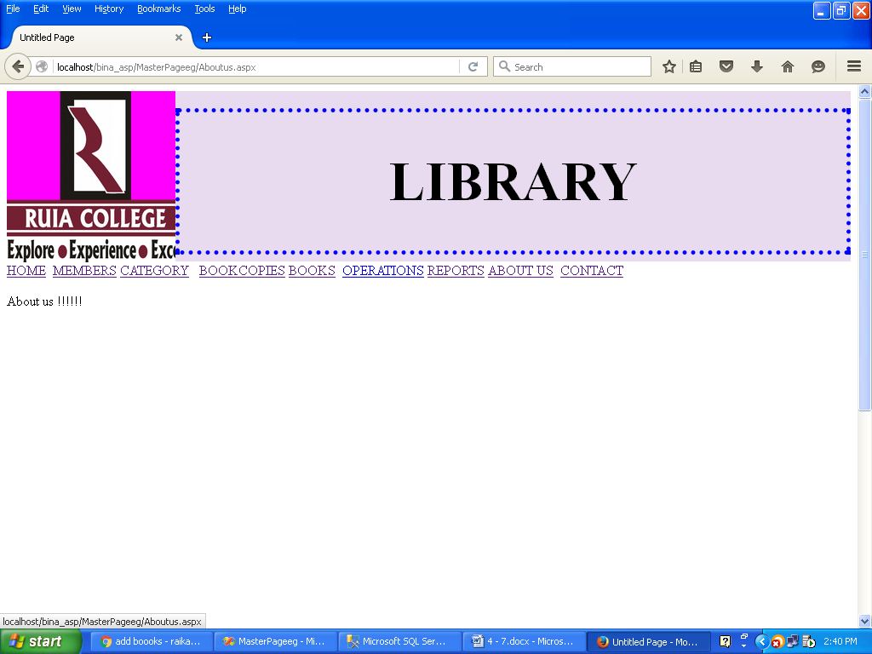

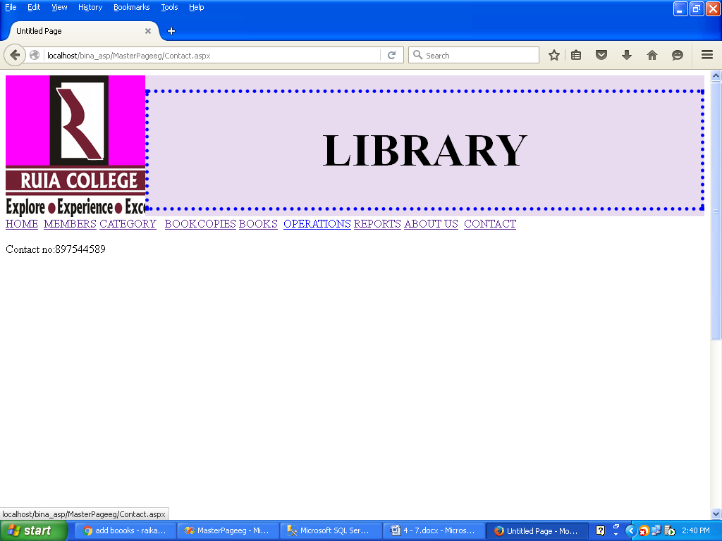

**PRACTICAL NO 5**

**AIM:** To study about autopost back and to implement the same in library website to update and delete category

**INPUT:**

**UpdateCategory.aspx**

<%@ Page Language="VB" MasterPageFile="~/MasterPage.master" AutoEventWireup="false" CodeFile="UpdateCategory.aspx.vb" Inherits="UpdateCategory" title="Update Category" %>

<asp:Content ID="Content1" ContentPlaceHolderID="head" Runat="Server">

<style type="text/css">

.style1

{

height: 60px;

}

.style2

{

height: 28px;

}

.style3

{

height: 61px;

}

.style4

{

height: 73px;

}

</style>

</asp:Content>

<asp:Content ID="Content2" ContentPlaceHolderID="ContentPlaceHolder1" Runat="Server">

<div>

<table style="width:100%;">

<tr>

<td class="style2" colspan="2">

&nbsp;&nbsp;&nbsp;&nbsp;&nbsp;&nbsp;&nbsp;&nbsp;&nbsp;&nbsp;&nbsp;&nbsp;&nbsp;&nbsp;&nbsp;&nbsp;&nbsp;&nbsp;&nbsp;&nbsp;&nbsp;&nbsp;&nbsp;&nbsp;&nbsp;&nbsp;&nbsp;&nbsp;&nbsp;&nbsp;&nbsp;&nbsp;&nbsp;&nbsp;&nbsp;&nbsp;&nbsp;&nbsp;&nbsp;&nbsp;&nbsp;&nbsp;&nbsp;&nbsp;&nbsp;&nbsp;&nbsp;&nbsp;&nbsp;&nbsp;&nbsp;&nbsp;&nbsp;&nbsp;&nbsp;&nbsp;&nbsp;&nbsp;&nbsp;&nbsp;&nbsp;&nbsp;&nbsp;&nbsp;&nbsp;&nbsp;&nbsp;&nbsp;&nbsp;&nbsp;&nbsp;&nbsp;&nbsp;&nbsp;&nbsp;&nbsp;&nbsp;&nbsp;&nbsp;&nbsp;&nbsp;&nbsp;&nbsp;&nbsp;&nbsp;&nbsp;&nbsp;&nbsp;&nbsp;&nbsp;&nbsp;&nbsp;&nbsp;&nbsp;&nbsp;&nbsp;&nbsp;

UPDATE CATEGORY</td>

</tr>

<tr>

<td class="style1">

CATEGORY ID:</td>

<td class="style1">

<asp:DropDownList ID="DropDownList1" runat="server"

DataSourceID="SqlDataSource1" DataTextField="category_id"

DataValueField="category_id">

</asp:DropDownList>

<asp:SqlDataSource ID="SqlDataSource1" runat="server"

ConnectionString="<%$ ConnectionStrings:RuiaLibraryConnectionString %>"

SelectCommand="SELECT [category_id] FROM [Category]"></asp:SqlDataSource>

</td>

</tr>

<tr>

<td class="style3">

CATEGORY NAME:</td>

<td class="style3">

<asp:TextBox ID="txtcatname" runat="server"></asp:TextBox>

</td>

</tr>

<tr>

<td class="style4">

<asp:Button ID="btnUpdate" runat="server" Text="Update" />

</td>

<td class="style4">

<asp:Button ID="btnCancel" runat="server" Text="Cancel" Width="76px" />

</td>

</tr>

<tr>

<td class="style4">

<asp:Label ID="lblmsg" runat="server" Text="Label"></asp:Label>

</td>

<td class="style4">

&nbsp;</td>

</tr>

</table>

</div>

</asp:Content>

**UpdateCategoty.aspx.vb**

Imports System.Data

Imports System.Data.SqlClient

Imports System.Web.Configuration

Partial Class UpdateCategory

Inherits System.Web.UI.Page

Protected Sub DropDownList1_SelectedIndexChanged(ByVal sender As Object, ByVal e As System.EventArgs) Handles DropDownList1.SelectedIndexChanged

End Sub

Protected Sub Page_Load(ByVal sender As Object, ByVal e As System.EventArgs) Handles Me.Load

Dim objcon As New SqlConnection(WebConfigurationManager.ConnectionStrings("DBCon").ConnectionString)

Dim strquery As String = "Select * from Category"

Dim objcmd As New SqlCommand(strquery, objcon)

Try

objcon.Open()

Dim objread As SqlDataReader = objcmd.ExecuteReader()

While objread.Read()

DropDownList1.Items.Add(objread(0))

End While

Catch ex As Exception

End Try

End Sub

Protected Sub btnUpdate_Click(ByVal sender As Object, ByVal e As System.EventArgs) Handles btnUpdate.Click

Dim objcon As New SqlConnection(WebConfigurationManager.ConnectionStrings("DBCon").ConnectionString)

Dim strquery As String = "Update Category set category_name=@cat_name where category_id=@cat_id"

Dim objcmd As New SqlCommand(strquery, objcon)

objcmd.Parameters.AddWithValue("@cat_id", DropDownList1.SelectedItem.Text)

objcmd.Parameters.AddWithValue("@cat_name", txtcatname.Text)

Try

objcon.Open()

Dim intflag As Integer = objcmd.ExecuteNonQuery()

If intflag > 0 Then

lblmsg.Text = "<b>" & "Record Updated successfully" & "</b>"

txtcatname.Text = ""

End If

Catch ex As Exception

Throw ex

Finally

objcon.Close()

End Try

End Sub

End Class

**OUTPUT:**

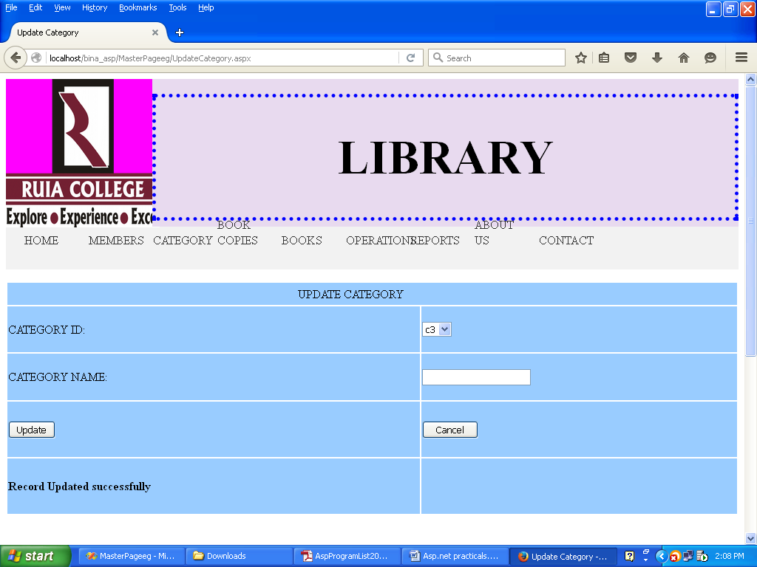

**INPUT:**

**DeleteCategory.aspx**

<%@ Page Language="VB" MasterPageFile="~/MasterPage.master" AutoEventWireup="false" CodeFile="DeleteCategory.aspx.vb" Inherits="DeleteCategory" title="Delete Category" %>

<asp:Content ID="Content1" ContentPlaceHolderID="head" Runat="Server">

</asp:Content>

<asp:Content ID="Content2" ContentPlaceHolderID="ContentPlaceHolder1" Runat="Server">

<table style="width:100%;">

<tr>

<td class="style2" colspan="2">

&nbsp;&nbsp;&nbsp;&nbsp;&nbsp;&nbsp;&nbsp;&nbsp;&nbsp;&nbsp;&nbsp;&nbsp;&nbsp;&nbsp;&nbsp;&nbsp;&nbsp;&nbsp;&nbsp;&nbsp;&nbsp;&nbsp;&nbsp;&nbsp;&nbsp;&nbsp;&nbsp;&nbsp;&nbsp;&nbsp;&nbsp;&nbsp;&nbsp;&nbsp;&nbsp;&nbsp;&nbsp;&nbsp;&nbsp;&nbsp;&nbsp;&nbsp;&nbsp;&nbsp;&nbsp;&nbsp;&nbsp;&nbsp;&nbsp;&nbsp;&nbsp;&nbsp;&nbsp;&nbsp;&nbsp;&nbsp;&nbsp;&nbsp;&nbsp;&nbsp;&nbsp;&nbsp;&nbsp;&nbsp;&nbsp;&nbsp;&nbsp;&nbsp;&nbsp;&nbsp;&nbsp;&nbsp;&nbsp;&nbsp;&nbsp;&nbsp;&nbsp;&nbsp;&nbsp;&nbsp;&nbsp;&nbsp;&nbsp;&nbsp;&nbsp;&nbsp;&nbsp;&nbsp;&nbsp;&nbsp;&nbsp;&nbsp;&nbsp;&nbsp;&nbsp;&nbsp;&nbsp;

DELETE CATEGORY</td>

</tr>

<tr>

<td class="style1">

CATEGORY NAME:</td>

<td class="style1">

<asp:DropDownList ID="DropDownList1" runat="server"

DataSourceID="SqlDataSource1" DataTextField="category_name"

DataValueField="category_name" AutoPostBack="True">

</asp:DropDownList>

<asp:SqlDataSource ID="SqlDataSource1" runat="server"

ConnectionString="<%$ ConnectionStrings:RuiaLibraryConnectionString %>"

SelectCommand="SELECT [category_name] FROM [Category]"></asp:SqlDataSource>

</td>

</tr>

<tr>

<td class="style3">

&nbsp;</td>

<td class="style3">

&nbsp;</td>

</tr>

<tr>

<td class="style4">

<asp:Button ID="btnDelete" runat="server" Text="Delete" />

</td>

<td class="style4">

&nbsp;</td>

</tr>

<tr>

<td class="style4">

<asp:Label ID="lblmsg" runat="server" Text="Label"></asp:Label>

</td>

<td class="style4">

&nbsp;</td>

</tr>

</table>

</asp:Content>

**DeleteCategory.aspx.vb**

Imports System.Data

Imports System.Data.SqlClient

Imports System.Web.Configuration

Partial Class DeleteCategory

Inherits System.Web.UI.Page

Dim objcon As SqlConnection = DBConnection.GetConnection

Protected Sub Page_Load(ByVal sender As Object, ByVal e As System.EventArgs) Handles Me.Load

End Sub

Protected Sub btnDelete_Click(ByVal sender As Object, ByVal e As System.EventArgs) Handles btnDelete.Click

Dim strquery As String = "Delete from Category where category_name=@cat_name"

Dim objcmd As New SqlCommand(strquery, objcon)

objcmd.Parameters.AddWithValue("@cat_name", DropDownList1.SelectedItem.Text)

Try

objcon.Open()

Dim intflag As Integer = objcmd.ExecuteNonQuery()

If intflag > 0 Then

lblmsg.Text = "<b>" & "Record Deleted successfully" & "</b>"

End If

Catch ex As Exception

Throw ex

Finally

objcon.Close()

End Try

End Sub

End Class

**OUTPUT:**

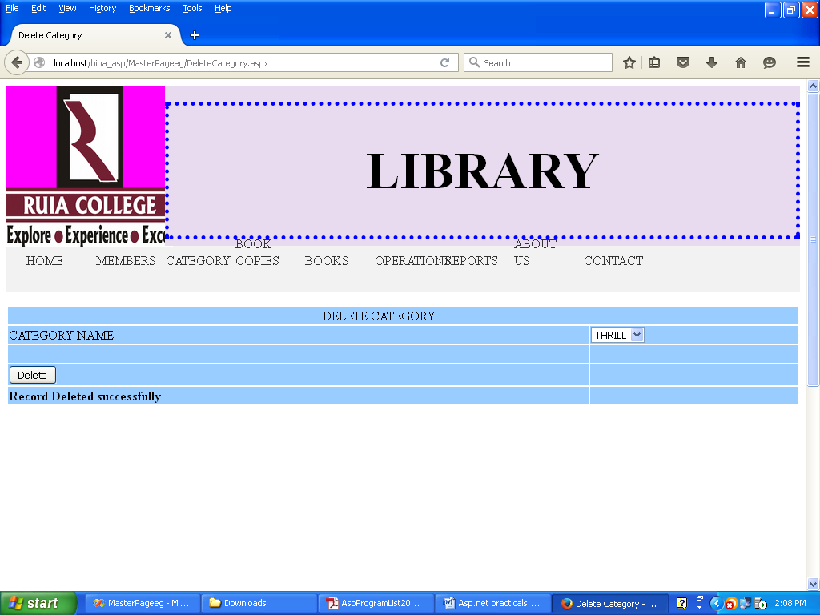

**PRACTICAL NO 6**

**AIM:**To study about session and state management

**INPUT:**

**AdminLogin.aspx**

<%@ Page Language="VB" AutoEventWireup="false" CodeFile="AdminLogin.aspx.vb" Inherits="AdminLogin" %>

<!DOCTYPE html PUBLIC "-//W3C//DTD XHTML 1.0 Transitional//EN" "http://www.w3.org/TR/xhtml1/DTD/xhtml1-transitional.dtd">

<html xmlns="http://www.w3.org/1999/xhtml">

<head runat="server">

<title>Untitled Page</title>

</head>

<body>

<form id="form1" runat="server">

<div>

<center>

<table style="border-color: #000000; border-style: groove; width: 48%; height: 344px;">

<tr>

<td class="style2" colspan="2">

&nbsp; &nbsp;&nbsp;&nbsp;&nbsp;LOGIN FORM</td>

</tr>

<tr>

<td class="style3">

&nbsp;

USERNAME:</td>

<td>

<asp:TextBox ID="txtUserName" runat="server" Height="28px"></asp:TextBox>

</td>

</tr>

<tr>

<td class="style3">

&nbsp;&nbsp; PASSWORD</td>

<td>

<asp:TextBox ID="txtPassword" runat="server" Height="31px"></asp:TextBox>

</td>

</tr>

<tr>

<td class="style3">

&nbsp;

<asp:Button ID="btnLogin" runat="server" Text="Login" BackColor="Lime"

BorderColor="Black" BorderStyle="Outset" Font-Bold="True" Height="35px"

Width="66px" />

</td>

<td style="border-color: #000000">

&nbsp;

<asp:Button ID="btnReset" runat="server" Text="Reset" BackColor="#FF5050"

BorderColor="Black" Font-Bold="True" Height="36px" Width="67px" />

</td>

</tr>

<tr>

<td class="style1" colspan="2">

<asp:Label ID="lblMessage" runat="server"></asp:Label>

</td>

</tr>

</table>

</center>

</div>

</form>

</body>

</html>

**AdminLogin.aspx.vb**

Imports System.Data

Imports System.Data.SqlClient

Imports System.Web.Configuration

Partial Class AdminLogin

Inherits System.Web.UI.Page

Protected Sub btnLogin_Click(ByVal sender As Object, ByVal e As System.EventArgs) Handles btnLogin.Click

Dim objcon As New SqlConnection(WebConfigurationManager.ConnectionStrings("DBCon").ConnectionString)

objcon.Open()

Dim strquery As String

strquery = "Select * from AdminLogin where username=@u and password=@p"

Dim sqlcmd As New SqlCommand(strquery, objcon)

sqlcmd.Parameters.AddWithValue("@u", txtUserName.Text)

sqlcmd.Parameters.AddWithValue("@p", txtPassword.Text)

Dim objRead As SqlDataReader

objRead = sqlcmd.ExecuteReader()

If objRead.Read Then

Session("user") = txtUserName.Text

Response.Redirect("Home.aspx")

Else

Response.Redirect("errorpage.aspx")

End If

End Sub

Protected Sub btnReset_Click(ByVal sender As Object, ByVal e As System.EventArgs) Handles btnReset.Click

txtUserName.Text = ""

txtPassword.Text = ""

End Sub

End Class

**OUTPUT:**







**PRACTICAL NO 7**

**AIM:**To study about Using ASP.NET validation controls, ADRotator controls and fileupload control

**INPUT:**

**XML File:**

<?xml version="1.0" encoding="utf-8" ?>

<Advertisements>

<Ad>

<ImageUrl>camel.jpg</ImageUrl>

<NavigateUrl>http://www.google.com</NavigateUrl>

<AlternateText>Penguin</AlternateText>

<Impression></Impression>

<Keyword>Animal</Keyword>

</Ad>

<Ad>

<ImageUrl>deer.jpg</ImageUrl>

<NavigateUrl>http://www.google.com</NavigateUrl>

<AlternateText>Penguin</AlternateText>

<Impression></Impression>

<Keyword>Animal</Keyword>

</Ad>

</Advertisements>

**.aspx**

<%@ Page Language="C#" AutoEventWireup="true" CodeFile="Default.aspx.cs" Inherits="_Default" %>

<!DOCTYPE html PUBLIC "-//W3C//DTD XHTML 1.0 Transitional//EN" "http://www.w3.org/TR/xhtml1/DTD/xhtml1-transitional.dtd">

<html xmlns="http://www.w3.org/1999/xhtml">

<head runat="server">

<title></title>

</head>

<body>

<form id="form1" runat="server">

<div>

<div style="height: 520px">

<div style="height: 88px">

</div>

<div style="width: 404px">

<table style="width:151%;">

<tr>

<td class="style1">

Name</td>

<td class="style2">

<asp:TextBox ID="txtName" runat="server"></asp:TextBox>

<asp:RequiredFieldValidator ID="rfvName" runat="server"

ControlToValidate="txtName" ErrorMessage="Please Enter Name"></asp:RequiredFieldValidator>

</td>

<td rowspan="6">

<asp:AdRotator ID="AdRotator1" runat="server" AdvertisementFile="~/XMLFile.xml"

Height="30%" Width="50%" />

</td>

</tr>

<tr>

<td class="style1">

Age</td>

<td class="style2">

<asp:TextBox ID="txtAge" runat="server"></asp:TextBox>

<asp:RangeValidator ID="rvAge" runat="server"

ControlToValidate="txtAge" ErrorMessage="Age between 18 &amp; 60"

MaximumValue="60" MinimumValue="18" ForeColor="Red"></asp:RangeValidator>

</td>

</tr>

<tr>

<td class="style1">

Email-Id</td>

<td class="style2">

<asp:TextBox ID="txtEmail" runat="server"></asp:TextBox>

<asp:RegularExpressionValidator ID="revEmail" runat="server"

ControlToValidate="txtEmail" ErrorMessage="Enter valid email id"

ForeColor="Red" ValidationExpression="\w*?.\w*@\w*\.\w*"></asp:RegularExpressionValidator>

</td>

</tr>

<tr>

<td class="style1">

Mobile</td>

<td class="style2">

<asp:TextBox ID="txtMobile" runat="server" MaxLength="10"

style="margin-bottom: 0px"></asp:TextBox>

<asp:RequiredFieldValidator ID="rfvMobile" runat="server"

ForeColor="Red" ControlToValidate="txtMobile" ErrorMessage="Enter Mobile Please"></asp:RequiredFieldValidator>

</td>

</tr>

<tr>

<td class="style1">

Enter Password</td>

<td class="style2">

<asp:TextBox ID="txtPassword" runat="server"></asp:TextBox>

</td>

</tr>

<tr>

<td class="style1">

RE-enter Password</td>

<td class="style2">

<asp:TextBox ID="txtRePassword" runat="server"></asp:TextBox>

<asp:CompareValidator ID="cvConfirmPassword" runat="server"

ControlToCompare="txtPassword" ControlToValidate="txtRePassword"

ForeColor="Red" ErrorMessage="Wrong Password"></asp:CompareValidator>

</td>

</tr>

<tr>

<td class="style1">

<asp:Button ID="btnsubmit" runat="server" Text="Submit" />

</td>

<td class="style2">

<asp:Button ID="btncancel" runat="server" Text="Cancel" />

</td>

<td rowspan="2">

<asp:AdRotator ID="AdRotator2" runat="server" AdvertisementFile="~/XMLFile.xml"

Height="30%" Width="50%" />

</td>

</tr>

<tr>

<td class="style1">

&nbsp;</td>

<td class="style2">

&nbsp;</td>

</tr>

</table>

<div style="height: 99px">

</div>

</div>

</div>

</div>

</form>

</body>

</html>

**OUTPUT:**

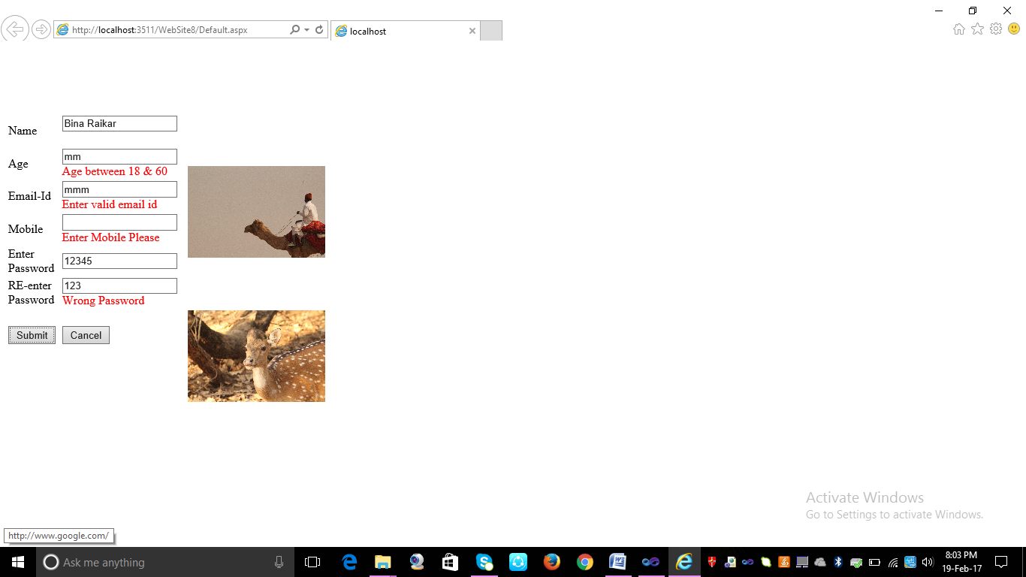

**INPUT:**

**Home.aspx**

<%@ Page Language="VB" AutoEventWireup="false" CodeFile="Home.aspx.vb" Inherits="Home" %>

<!DOCTYPE html PUBLIC "-//W3C//DTD XHTML 1.0 Transitional//EN" "http://www.w3.org/TR/xhtml1/DTD/xhtml1-transitional.dtd">

<html xmlns="http://www.w3.org/1999/xhtml">

<head runat="server">

<title>Untitled Page</title>

</head>

<body>

<form id="form1" runat="server">

<div>

<asp:LinkButton ID="LinkButtonUploadPhoto" runat="server" Font-Size="XX-Large">Upload Photo</asp:LinkButton>

&nbsp;&nbsp;&nbsp;&nbsp;&nbsp;&nbsp;

<asp:LinkButton ID="LinkButtonFetchPhoto" runat="server" Font-Size="XX-Large">Fetch Photo</asp:LinkButton>

</div>

</form>

</body>

</html>

**Home.aspx.vb**

Partial Class Home

Inherits System.Web.UI.Page

Protected Sub LinkButtonUploadPhoto_Click(ByVal sender As Object, ByVal e As System.EventArgs) Handles LinkButtonUploadPhoto.Click

Response.Redirect("UploadPhoto.aspx")

End Sub

Protected Sub LinkButtonFetchPhoto_Click(ByVal sender As Object, ByVal e As System.EventArgs) Handles LinkButtonFetchPhoto.Click

Response.Redirect("FetchPhoto.aspx")

End Sub

End Class

**OUTPUT:**

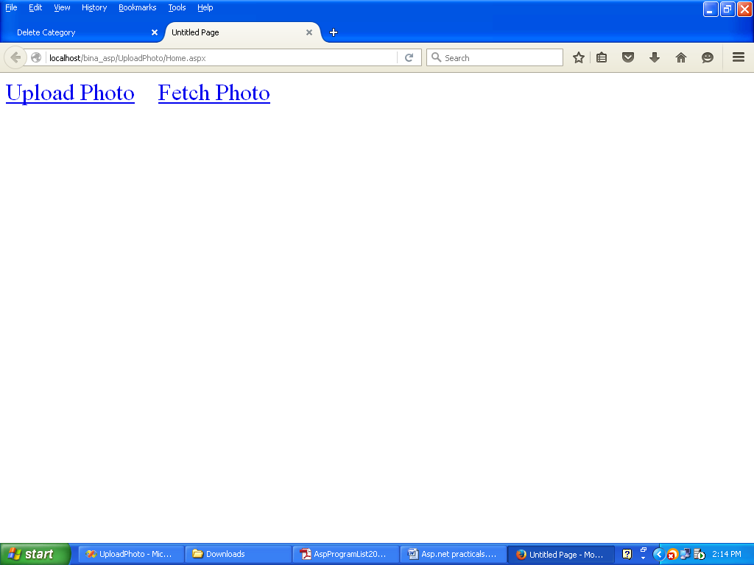

**INPUT:**

**UploadPhoto.aspx**

<%@ Page Language="VB" AutoEventWireup="false" CodeFile="UploadPhoto.aspx.vb" Inherits="UploadPhoto" %>

<!DOCTYPE html PUBLIC "-//W3C//DTD XHTML 1.0 Transitional//EN" "http://www.w3.org/TR/xhtml1/DTD/xhtml1-transitional.dtd">

<html xmlns="http://www.w3.org/1999/xhtml">

<head runat="server">

<title>Untitled Page</title>

<style type="text/css">

.style1

{

height: 46px;

}

.style2

{

height: 44px;

}

.style3

{

height: 58px;

}

.style4

{

height: 43px;

}

.style5

{

height: 45px;

}

</style>

</head>

<body>

<form id="form1" runat="server">

<div>

<asp:LinkButton ID="LinkButtonBack" runat="server">Back</asp:LinkButton>

<br />

<br />

<table>

<tr>

<td class="style1">

Enter Stduent ID:

</td>

<td class="style1">

<asp:TextBox ID="txtStudentID" runat="server"></asp:TextBox>

</td>

</tr>

<tr>

<br />

<td class="style2">

Enter Student Name:

</td>

<td class="style2">

<asp:TextBox ID="txtStudentName" runat="server"></asp:TextBox>

</td>

</tr>

<tr>

<td class="style2">

Upload Photo:

</td>

<td class="style2">

<asp:FileUpload ID="FileUploadPhoto" runat="server" />

</td>

<td class="style2">

<asp:Label ID="lblMsg" runat="server"></asp:Label>

</td>

</tr>

<tr>

<td class="style3">

<asp:Button ID="btnSubmit" runat="server" Text="Submit" />

</td>

<td class="style3">

<asp:Button ID="btnReset" runat="server" Text="Reset" />

</td>

</tr>

<tr>

<td class="style4">

File Path:

</td>

<td class="style4">

<asp:Label ID="lblFilePath" runat="server"></asp:Label>

</td>

</tr>

<tr>

<td class="style2">

File Name:

</td>

<td class="style2">

<asp:Label ID="lblFileName" runat="server"></asp:Label>

</td>

</tr>

<tr>

<td class="style5">

Error:

</td>

<td class="style5">

<asp:Label ID="lblError" runat="server"></asp:Label>

</td>

</tr>

</table>

</div>

</form>

</body></html>

**UploadPhoto.aspx.vb**

Imports System.Data

Imports System.Data.SqlClient

Partial Class UploadPhoto

Inherits System.Web.UI.Page

Protected Sub LinkButtonBack_Click(ByVal sender As Object, ByVal e As System.EventArgs) Handles LinkButtonBack.Click

Response.Redirect("Home.aspx")

End Sub

Dim objcon As New SqlConnection("Data Source=it_61\sqlexpress;Initial Catalog=FileUploadEg;Integrated Security=True")

Dim strQuery, strFile, strPath As String

Protected Sub btnSubmit_Click(ByVal sender As Object, ByVal e As System.EventArgs) Handles btnSubmit.Click

Dim intStatus As Integer

objcon.Open()

strQuery = "insert into UploadPhoto values(@Studentid,@StudentName,@File)"

If FileUploadPhoto.HasFile Then

strFile = FileUploadPhoto.FileName

Dim objcmd As New SqlCommand(strQuery, objcon)

objcmd.Parameters.AddWithValue("@Studentid", txtStudentID.Text)

objcmd.Parameters.AddWithValue("@StudentName", txtStudentName.Text)

objcmd.Parameters.AddWithValue("@File", strFile)

intStatus = objcmd.ExecuteNonQuery

strPath = Server.MapPath("~/images/") & strFile

FileUploadPhoto.PostedFile.SaveAs(strPath)

If intStatus > 0 Then

lblMsg.Text = "File Uploaded"

txtStudentID.Text = ""

txtStudentName.Text = ""

End If

Else

lblError.Text = "Please select the photo"

End If

lblFileName.Text = strFile

lblFilePath.Text = strPath

End Sub

End Class

**OUTPUT:**

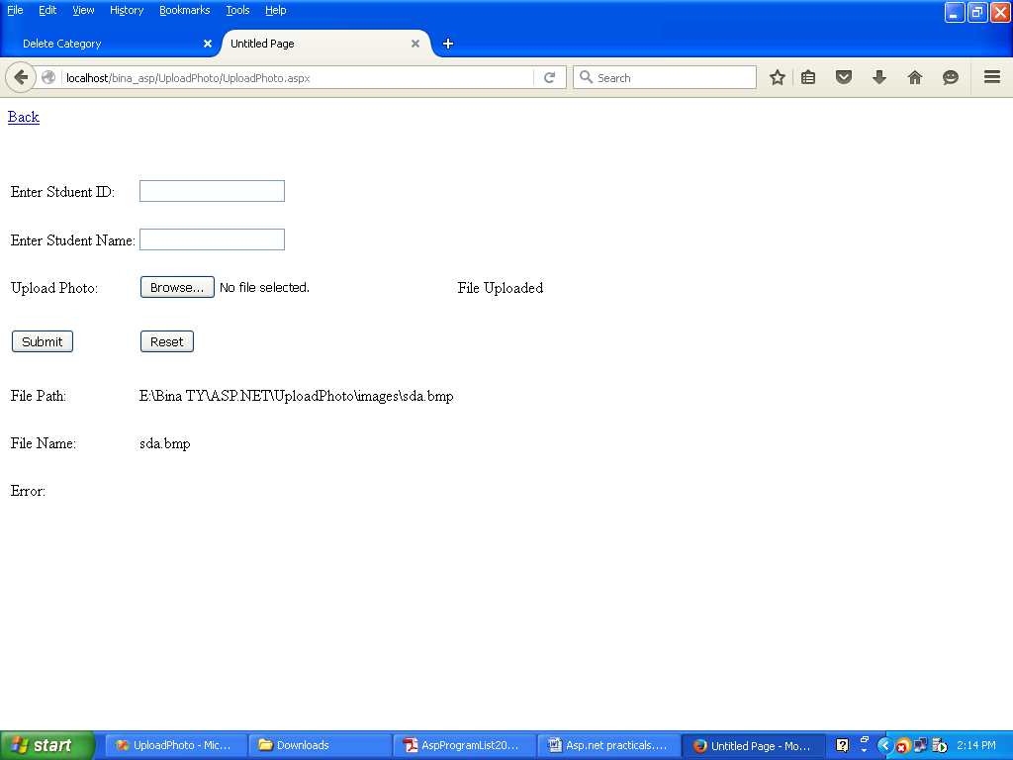

**INPUT:**

**FetchPhoto.aspx**

<%@ Page Language="VB" AutoEventWireup="false" CodeFile="FetchPhoto.aspx.vb" Inherits="FetchPhoto"%>

<!DOCTYPE html PUBLIC "-//W3C//DTD XHTML 1.0 Transitional//EN" "http://www.w3.org/TR/xhtml1/DTD/xhtml1-transitional.dtd">

<html xmlns="http://www.w3.org/1999/xhtml">

<head runat="server">

<title>Untitled Page</title>

<style type="text/css">

.style1

{

height: 80px;

}

.style2

{

height: 44px;

}

</style>

</head>

<body>

<form id="form1" runat="server">

<div>

<asp:LinkButton ID="LinkButtonBack" runat="server">Back</asp:LinkButton>

<br />

<br />

<br />

<table>

<tr>

<td class="style1">

Select Student Id:

</td>

<td class="style1">

<asp:DropDownList ID="DropDownListStudentId" runat="server"

DataSourceID="SqlDataSource1" DataTextField="id" DataValueField="id"

style="height: 22px" AutoPostBack="True" Height="22px"></asp:DropDownList>

<asp:SqlDataSource ID="SqlDataSource1" runat="server"

ConnectionString="<%$ ConnectionStrings:FileUploadEgConnectionString %>"

SelectCommand="SELECT [id] FROM [UploadPhoto]"></asp:SqlDataSource>

</td>

</tr>

<tr>

<td>

<asp:Button ID="btnSelectPhoto" runat="server" Text="Select Photo" />

</td>

</tr>

<tr>

<asp:Label ID="lblFile" runat="server"></asp:Label>

</tr>

<tr>

<td class="style2">

Student Id:

</td>

<td class="style2">

<asp:Label ID="lblStudentId" runat="server"></asp:Label>

</td>

</tr>

<tr>

<td class="style2">

Student Name:

</td>

<td class="style2">

<asp:Label ID="lblStudentName" runat="server"></asp:Label>

</td>

</tr>

<tr>

<td>

<asp:Image ID="imgFetchPhoto" runat="server"

ImageUrl="~/1_extra_1aeplf03.jpg" Height="150px" Width="150px"/>

</table>

</div>

</form>

</body>

</html>

**FetchPhoto.aspx.vb**

Imports System.Data

Imports System.Data.SqlClient

Partial Class FetchPhoto

Inherits System.Web.UI.Page

Protected Sub LinkButtonBack_Click(ByVal sender As Object, ByVal e As System.EventArgs) Handles LinkButtonBack.Click

Response.Redirect("Home.aspx")

End Sub

Dim objcon As New SqlConnection("Data Source=it_61\sqlexpress;Initial Catalog=FileUploadEg;Integrated Security=True")

Dim strQuery, strFile, strPath As String

Protected Sub DropDownListStudentId_SelectedIndexChanged(ByVal sender As Object, ByVal e As System.EventArgs) Handles DropDownListStudentId.SelectedIndexChanged

objcon.Open()

strQuery = "Select * from UploadPhoto where id=" & DropDownListStudentId.SelectedItem.ToString

Dim objCmd As New SqlCommand(strQuery, objcon)

Dim objRead As SqlDataReader = objCmd.ExecuteReader

objRead.Read()

lblStudentId.Text = objRead(0)

lblStudentName.Text = objRead(1)

strFile = objRead(2)

lblFile.Text = Server.MapPath("~/images/") & strFile

imgFetchPhoto.ImageUrl = "~/images/" & strFile

End Sub

End Class

**OUTPUT:**

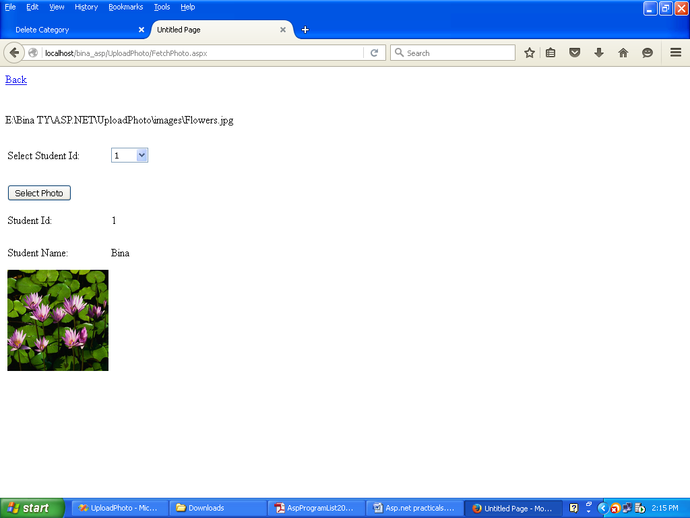

**PRACTICAL NO 8**

**AIM:** To study about complex data binding using SQL Datasource control

**INPUT:**

**HomePage.aspx**

<%@ Page Language="VB" AutoEventWireup="false" CodeFile="HomePage.aspx.vb" Inherits="HomePage" %>

<!DOCTYPE html PUBLIC "-//W3C//DTD XHTML 1.0 Transitional//EN" "http://www.w3.org/TR/xhtml1/DTD/xhtml1-transitional.dtd">

<html xmlns="http://www.w3.org/1999/xhtml">

<head runat="server">

<title>Untitled Page</title>

<style type="text/css">

.style1

{

height: 48px;

}

</style>

</head>

<body>

<form id="form1" runat="server">

<div>

<asp:LinkButton ID="lnkBtnAddNewProperty" runat="server">Add New Property</asp:LinkButton>

&nbsp&nbsp;&nbsp;&nbsp;&nbsp;&nbsp;&nbsp;&nbsp;&nbsp;&nbsp;&nbsp;&nbsp;&nbsp;&nbsp;&nbsp;&nbsp;&nbsp;&nbsp;&nbsp;&nbsp;&nbsp;&nbsp;&nbsp;

<asp:LinkButton ID="lnkBtnShow" runat="server">Show</asp:LinkButton><br /><br />

<asp:Panel ID="panelAddNewPropertyForm" runat="server" Height="389px"

Visible="False">

<table style="height: 216px">

<tr>

<td class="style1">

Property No:

</td>

<td class="style1">

<asp:TextBox ID="txtPropertyNo" runat="server"></asp:TextBox>

</td>

</tr>

<tr>

<td class="style1">

Building:

</td>

<td class="style1">

<asp:TextBox ID="txtBuilding" runat="server"></asp:TextBox>

</td>

</tr>

<tr>

<td class="style1">

Rooms:

</td>

<td class="style1">

<asp:TextBox ID="txtRooms" runat="server"></asp:TextBox>

</td>

</tr>

<tr>

<td class="style1">

Suburbs:

</td>

<td class="style1">

<asp:TextBox ID="txtSuburbs" runat="server"></asp:TextBox>

</td>

</tr>

<tr>

<td class="style1">

City:

</td>

<td class="style1">

<asp:TextBox ID="txtCity" runat="server"></asp:TextBox>

</td>

</tr>

<tr>

<td class="style1">

Price:

</td>

<td class="style1">

<asp:TextBox ID="txtPrice" runat="server"></asp:TextBox>

</td>

</tr>

<tr>

<td><br /></td>

</tr>

<tr>

<td>

<asp:Button ID="btnAddNewProperty" runat="server" Text="Add New Property" />

</td>

<td>

<asp:Button ID="btnReset" runat="server" Text="Reset" />

</td>

</tr>

</table>

<asp:Label ID="lblErrorMsg" runat="server"></asp:Label>

</asp:Panel>

</div>

</form>

</body>

</html>

**HomePage.aspx.vb**

Imports System.Data

Imports System.Data.SqlClient

Imports System.Web.Configuration

Partial Class HomePage

Inherits System.Web.UI.Page

Protected Sub lnkBtnAddNewProperty_Click(ByVal sender As Object, ByVal e As System.EventArgs) Handles lnkBtnAddNewProperty.Click

panelAddNewPropertyForm.Visible = True

End Sub

Protected Sub btnAddNewProperty_Click(ByVal sender As Object, ByVal e As System.EventArgs) Handles btnAddNewProperty.Click

Dim objcon As New SqlConnection(WebConfigurationManager.ConnectionStrings("DBCon").ConnectionString)

Try

objcon.Open()

Dim strQuery As String = "Insert into AddNewProperty values (@propertyNo,@building,@rooms,@sub,@city,@price)"

Dim objcmd As New SqlCommand(strQuery, objcon)

objcmd.Parameters.AddWithValue("@propertyNo", txtPropertyNo.Text)

objcmd.Parameters.AddWithValue("@building", txtBuilding.Text)

objcmd.Parameters.AddWithValue("@rooms", txtRooms.Text)

objcmd.Parameters.AddWithValue("@sub", txtSuburbs.Text)

objcmd.Parameters.AddWithValue("@city", txtCity.Text)

objcmd.Parameters.AddWithValue("@price", txtPrice.Text)

Dim intStatus As String = objcmd.ExecuteNonQuery

If intStatus > 0 Then

Response.Redirect("SuccessPage.aspx")

Else

lblErrorMsg.Text = "Please enter proper values"

End If

Catch ex As Exception

ex.Message.ToString()

Finally

objcon.Close()

End Try

End Sub

Protected Sub Page_Load(ByVal sender As Object, ByVal e As System.EventArgs) Handles Me.Load

End Sub

Protected Sub btnReset_Click(ByVal sender As Object, ByVal e As System.EventArgs) Handles btnReset.Click

txtPropertyNo.Text = ""

txtBuilding.Text = ""

txtRooms.Text = ""

txtSuburbs.Text = ""

txtCity.Text = ""

txtPrice.Text = ""

End Sub

Protected Sub lnkBtnShow_Click(ByVal sender As Object, ByVal e As System.EventArgs) Handles lnkBtnShow.Click

Response.Redirect("ShowProperty.aspx")

End Sub

End Class

**OUTPUT:**

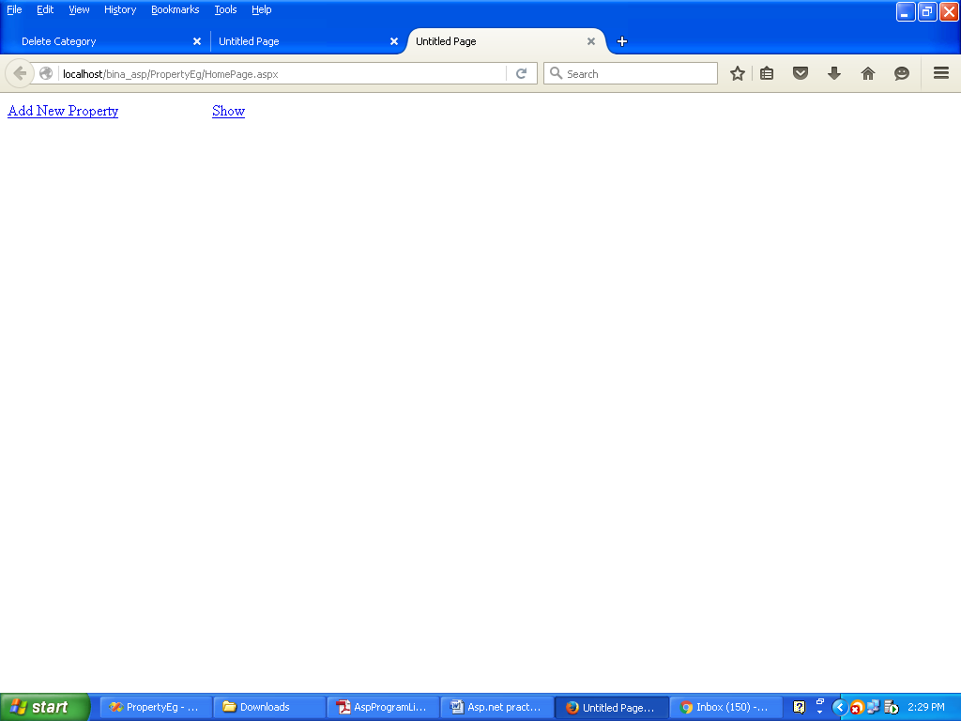

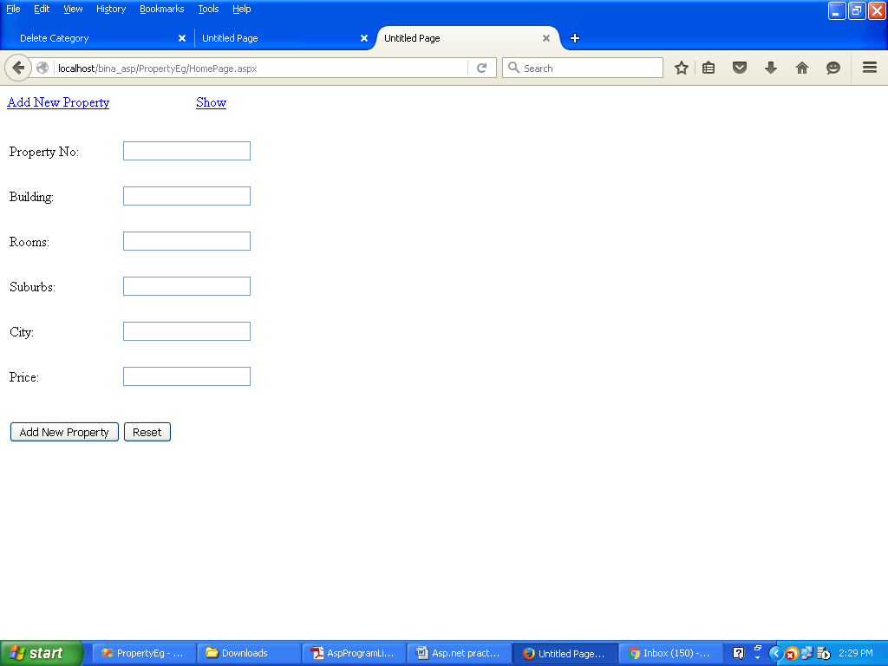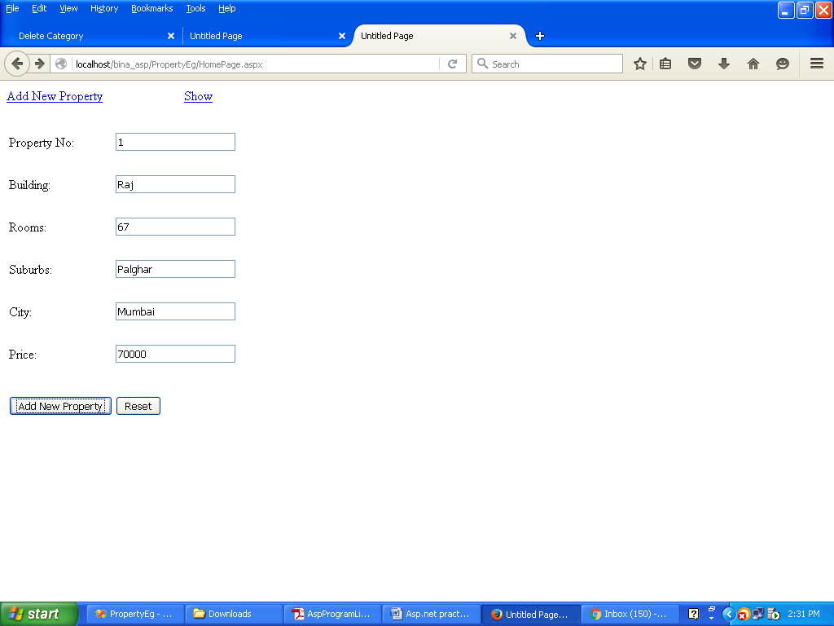

**INPUT:**

**SuccessPage.aspx**

<%@ Page Language="VB" AutoEventWireup="false" CodeFile="SuccessPage.aspx.vb" Inherits="SuccessPage" %>

<!DOCTYPE html PUBLIC "-//W3C//DTD XHTML 1.0 Transitional//EN" "http://www.w3.org/TR/xhtml1/DTD/xhtml1-transitional.dtd">

<html xmlns="http://www.w3.org/1999/xhtml">

<head runat="server">

<title>Untitled Page</title>

</head>

<body>

<form id="form1" runat="server">

<div>

<b>Record is inserted successfully. Please click

<asp:LinkButton ID="lnkBtnHere" runat="server">Here </asp:LinkButton> to go back</b>

</div>

</form>

</body>

</html>

**SuccessPage.aspx.vb**

Partial Class SuccessPage

Inherits System.Web.UI.Page

Protected Sub lnkBtnHere_Click(ByVal sender As Object, ByVal e As System.EventArgs) Handles lnkBtnHere.Click

Response.Redirect("HomePage.aspx")

End Sub

End Class

**OUTPUT:**

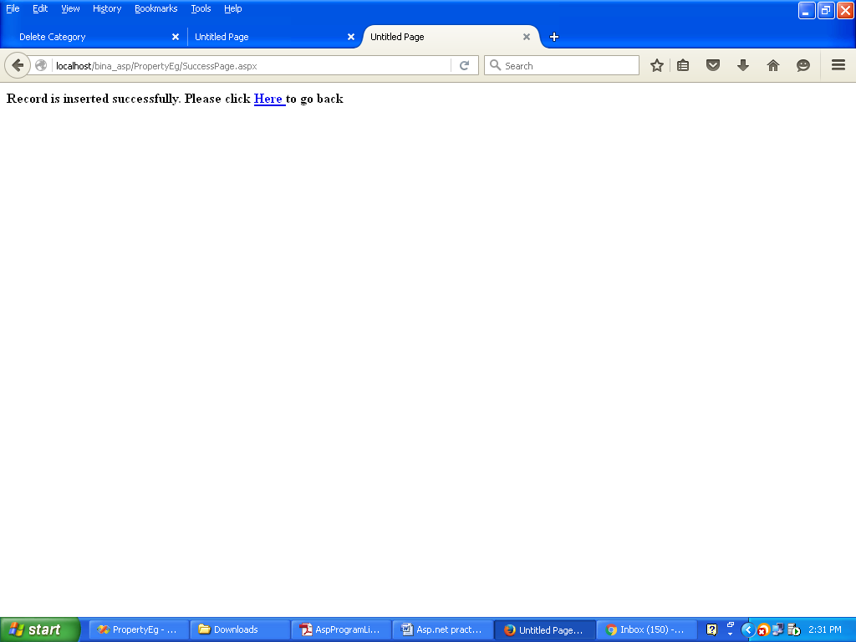

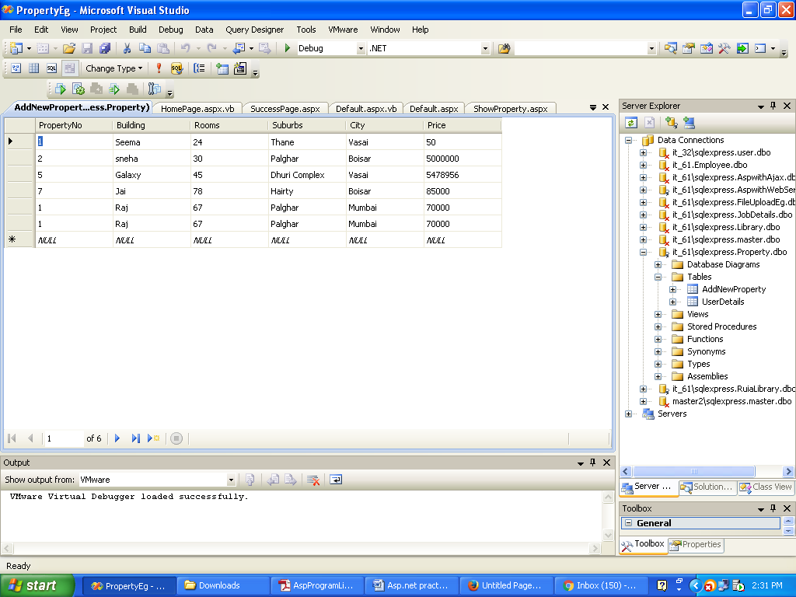

**INPUT:**

**ShowProperty.aspx**

<%@ Page Language="VB" AutoEventWireup="false" CodeFile="ShowProperty.aspx.vb" Inherits="ShowProperty" %>

<!DOCTYPE html PUBLIC "-//W3C//DTD XHTML 1.0 Transitional//EN" "http://www.w3.org/TR/xhtml1/DTD/xhtml1-transitional.dtd">

<html xmlns="http://www.w3.org/1999/xhtml">

<head runat="server">

<title>Untitled Page</title>

</head>

<body>

<form id="form1" runat="server">

<div>

<asp:DropDownList ID="DropDownList1" runat="server" AutoPostBack="True"

DataSourceID="SqlDataSource1" DataTextField="City" DataValueField="City">

</asp:DropDownList>

<asp:SqlDataSource ID="SqlDataSource1" runat="server"

ConnectionString="<%$ ConnectionStrings:PropertyConnectionString %>"

SelectCommand="SELECT DISTINCT [City] FROM [AddNewProperty]">

</asp:SqlDataSource>

<br />

</div>

<asp:Label ID="lblRooms" runat="server"></asp:Label>

<br />

<br />

<asp:Label ID="lblErrorMsg" runat="server"></asp:Label>

</form>

</body>

</html>

**ShowProperty.aspx.vb**

Imports System.Data

Imports System.Data.SqlClient

Imports System.Web.Configuration

Partial Class ShowProperty

Inherits System.Web.UI.Page

Protected Sub DropDownList1_SelectedIndexChanged(ByVal sender As Object, ByVal e As System.EventArgs) Handles DropDownList1.SelectedIndexChanged

Dim objcon As New SqlConnection(WebConfigurationManager.ConnectionStrings("DBCon").ConnectionString)

Dim strQuery As String

strQuery = "Select * from AddNewProperty where City=@city"

Dim objcmd As New SqlCommand(strQuery, objcon)

objcmd.Parameters.AddWithValue("@city", DropDownList1.SelectedItem.ToString)

Try

objcon.Open()

Dim objRead As SqlDataReader

objRead = objcmd.ExecuteReader

lblRooms.Text = "<table border=1><tr><th>Property No</th><th>Building</th><th>Rooms</th><th>Suburbs</th><th>City</th><th>Price:</th></tr>"

Do While objRead.Read

lblRooms.Text += "<tr>"

lblRooms.Text += "<td>" & objRead(0) & "</td>"

lblRooms.Text += "<td>" & objRead(1) & "</td>"

lblRooms.Text += "<td>" & objRead(2) & "</td>"

lblRooms.Text += "<td>" & objRead(3) & "</td>"

lblRooms.Text += "<td>" & objRead(4) & "</td>"

lblRooms.Text += "<td>" & objRead(5) & "</td>"

lblRooms.Text += "</tr>"

Loop

lblRooms.Text += "</table>"

Catch ex As Exception

lblErrorMsg.Text = ex.Message.ToString

Finally

objcon.Close()

End Try

End Sub

End Class

**OUTPUT:**

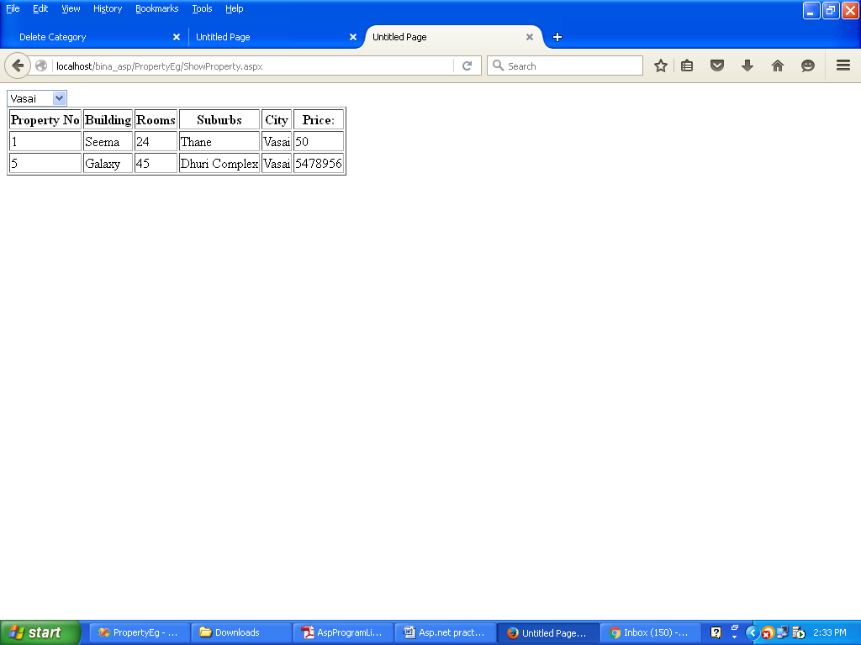

**PRACTICAL NO 9**

**AIM:** To study about datagridview control

**INPUT:**

**pract9.aspx**

<%@ Page Language="VB" AutoEventWireup="false" CodeFile="pract9.aspx.vb" Inherits="_Default" %>

<!DOCTYPE html PUBLIC "-//W3C//DTD XHTML 1.0 Transitional//EN" "http://www.w3.org/TR/xhtml1/DTD/xhtml1-transitional.dtd">

<html xmlns="http://www.w3.org/1999/xhtml">

<head runat="server">

<title>Untitled Page</title>

</head>

<body>

<form id="form1" runat="server">

<div>

<asp:GridView ID="GridView1" runat="server" AllowPaging="True"

AutoGenerateColumns="False" DataSourceID="SqlDataSource2"

DataKeyNames="srno">

<Columns>

<asp:CommandField ButtonType="Button" HeaderText="SELECT"

ShowSelectButton="True" />

<asp:CommandField ButtonType="Button" HeaderText="EDIT" ShowEditButton="True" />

<asp:CommandField ButtonType="Button" HeaderText="DELETE"

ShowDeleteButton="True" />

<asp:BoundField DataField="srno" HeaderText="srno" ReadOnly="True"

SortExpression="srno" />

<asp:BoundField DataField="CompanyName" HeaderText="CompanyName"

SortExpression="CompanyName" />

<asp:BoundField DataField="JobProfile" HeaderText="JobProfile"

SortExpression="JobProfile" />

<asp:BoundField DataField="Posting" HeaderText="Posting"

SortExpression="Posting" />

<asp:BoundField DataField="Salary" HeaderText="Salary"

SortExpression="Salary" />

<asp:BoundField DataField="JobDesc" HeaderText="JobDesc"

SortExpression="JobDesc" />

<asp:BoundField DataField="new" HeaderText="new" SortExpression="new" />

</Columns>

</asp:GridView>

<asp:SqlDataSource ID="SqlDataSource2" runat="server"

ConnectionString="<%$ ConnectionStrings:JobDetailsConnectionString %>"

DeleteCommand="DELETE FROM [Job] WHERE [srno] = @srno"

InsertCommand="INSERT INTO [Job] ([srno], [CompanyName], [JobProfile], [Posting], [Salary], [JobDesc], [new]) VALUES (@srno, @CompanyName, @JobProfile, @Posting, @Salary, @JobDesc, @new)"

SelectCommand="SELECT * FROM [Job]"

UpdateCommand="UPDATE [Job] SET [CompanyName] = @CompanyName, [JobProfile] = @JobProfile, [Posting] = @Posting, [Salary] = @Salary, [JobDesc] = @JobDesc, [new] = @new WHERE [srno] = @srno">

<DeleteParameters>

<asp:Parameter Name="srno" Type="String" />

</DeleteParameters>

<UpdateParameters>

<asp:Parameter Name="CompanyName" Type="String" />

<asp:Parameter Name="JobProfile" Type="String" />

<asp:Parameter Name="Posting" Type="String" />

<asp:Parameter Name="Salary" Type="Decimal" />

<asp:Parameter Name="JobDesc" Type="String" />

<asp:Parameter Name="new" Type="String" />

<asp:Parameter Name="srno" Type="String" />

</UpdateParameters>

<InsertParameters>

<asp:Parameter Name="srno" Type="String" />

<asp:Parameter Name="CompanyName" Type="String" />

<asp:Parameter Name="JobProfile" Type="String" />

<asp:Parameter Name="Posting" Type="String" />

<asp:Parameter Name="Salary" Type="Decimal" />

<asp:Parameter Name="JobDesc" Type="String" />

<asp:Parameter Name="new" Type="String" />

</InsertParameters>

</asp:SqlDataSource>

<br />

<br />

<asp:Label ID="lblMsg" runat="server"></asp:Label>

<br />

<asp:Label ID="lblStatus" runat="server"></asp:Label>

<br /><br /><br />

Company Name:<asp:Label ID="lblCompanyName" runat="server"></asp:Label>

<br /><br />

Job Profile:<asp:Label ID="lblJobProfile" runat="server"></asp:Label>

<br /><br />

Posting:<asp:Label ID="lblPosting" runat="server"></asp:Label>

<br /><br />

Salary<asp:Label ID="lblSalary" runat="server"></asp:Label>

<br /><br />

Job Description<asp:Label ID="lblJobDesc" runat="server"></asp:Label>

<br /><br />

New<asp:Label ID="lblNew" runat="server"></asp:Label>

<br /><br />

</div>

</form>

</body>

</html>

**pract9.aspx.vb**

Imports System.Data

Imports System.Data.SqlClient

Imports System.Web.Configuration

Partial Class _ pract9

Inherits System.Web.UI.Page

Protected Sub GridView1_SelectedIndexChanged(ByVal sender As Object, ByVal e As System.EventArgs) Handles GridView1.SelectedIndexChanged

Dim objcon As New SqlConnection(WebConfigurationManager.ConnectionStrings("JobDetailsConnectionString").ConnectionString)

objcon.Open()

lblMsg.Text = "Hello"

Dim strSelection As String = GridView1.SelectedValue

lblMsg.Text = strSelection

Dim strQuery As String = "Select * from Job where srno=@srno"

Dim objcmd As New SqlCommand(strQuery, objcon)

objcmd.Parameters.AddWithValue("@srno", strSelection)

Try

Dim objRead As SqlDataReader = objcmd.ExecuteReader

objRead.Read()

lblCompanyName.Text = "<b>" & objRead(1) & "</b>"

lblJobProfile.Text = "<b>" & objRead(2) & "</b>"

lblPosting.Text = "<b>" & objRead(3) & "</b>"

lblSalary.Text = "<b>" & objRead(4) & "</b>"

lblJobDesc.Text = "<b>" & objRead(5) & "</b>"

lblNew.Text = "<b>" & objRead(6) & "</b>"

Catch ex As Exception

lblMsg.Text = ex.Message.ToString()

End Try

End Sub

End Class

**OUTPUT:**

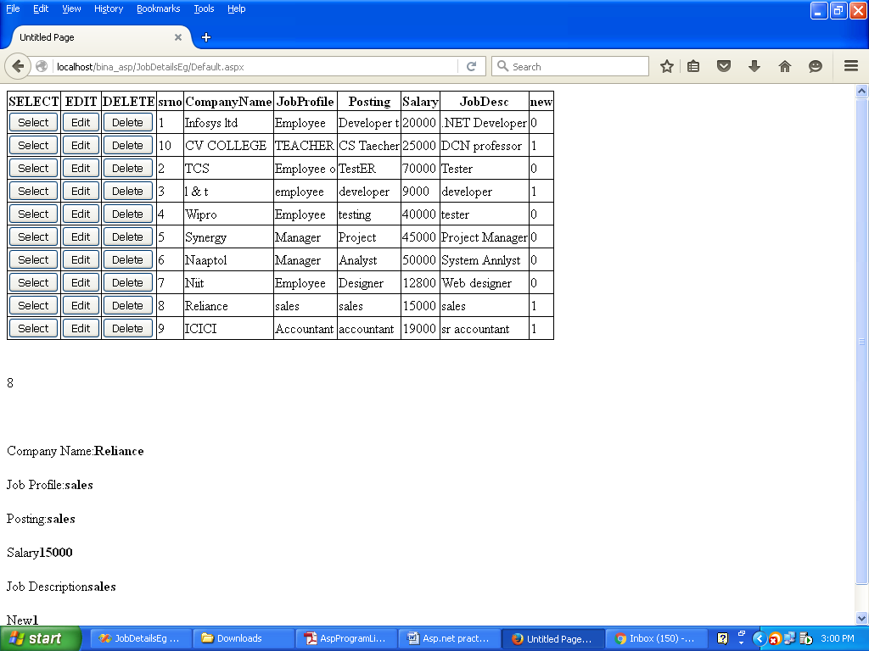

**PRACTICAL NO 10**

**AIM:** To study about using XML files as database for the website

**INPUT:**

**Channels.xml**

<?xml version="1.0" encoding="utf-8" ?>

<CableTV>

<Channel Name="DD News">

<Language>Hindi</Language>

<Category>News</Category>

</Channel>

<Channel Name="Star Tv">

<Language>Hindi</Language>

<Category>Drama</Category>

</Channel>

<Channel Name="HBO">

<Language>English</Language>

<Category>Films</Category>

</Channel>

<Channel Name="Colours">

<Language>Hindi</Language>

<Category>Drama</Category>

</Channel>

<Channel Name="Set Max">

<Language>Hindi</Language>

<Category>Films</Category>

</Channel>

<Channel Name="Zee Marathi">

<Language>Marathi</Language>

<Category>Drama</Category>

</Channel>

<Channel Name="Pogo">

<Language>Hindi</Language>

<Category>Cartoon</Category>

</Channel>

</CableTV>

**Pract10.aspx**

<%@ Page Language="VB" AutoEventWireup="false" CodeFile="Pract10.aspx.vb" Inherits="Pract10" %>

<!DOCTYPE html PUBLIC "-//W3C//DTD XHTML 1.0 Transitional//EN" "http://www.w3.org/TR/xhtml1/DTD/xhtml1-transitional.dtd">

<html xmlns="http://www.w3.org/1999/xhtml">

<head runat="server">

<title>Untitled Page</title>

</head>

<body>

<form id="form1" runat="server">

<div>

<h1>Reading Xml File</h1>

<br />

<br />

Select Language:<asp:DropDownList ID="ddlLanguage" runat="server">

<asp:ListItem Value="Hindi"></asp:ListItem>

<asp:ListItem>Marathi</asp:ListItem>

<asp:ListItem>English</asp:ListItem>

</asp:DropDownList>

<br /><br />

Select Category:<asp:DropDownList ID="ddlCategory" runat="server">

<asp:ListItem>Drama</asp:ListItem>

<asp:ListItem>Films</asp:ListItem>

<asp:ListItem>News</asp:ListItem>

<asp:ListItem>Cartoon</asp:ListItem>

</asp:DropDownList>

</div>

<br />

<br />

<asp:Button ID="btnDisplay" runat="server" Text="Display" />

<br />

<br />

Your channel list is:<asp:Label ID="lblList" runat="server"></asp:Label>

</form>

</body>

</html>

**Pract10.aspx.vb**

Imports System.Xml

Partial Class Pract10

Inherits System.Web.UI.Page

Protected Sub btnDisplay_Click(ByVal sender As Object, ByVal e As System.EventArgs) Handles btnDisplay.Click

Dim doc As XmlDocument

doc = New XmlDocument

Dim strpath As String

Dim intcount As Integer = 0

strpath = Server.MapPath("~/") & "Channels.xml"

lblList.Text = ""

doc.Load(strpath)

For Each element As XmlElement In doc.DocumentElement.ChildNodes

Dim channel As String

channel = element.GetAttribute("Name")

If element.ChildNodes(0).InnerText = ddlLanguage.Text And element.ChildNodes(1).InnerText = ddlCategory.Text Then

intcount += 1

lblList.Text = intcount & "," & channel & "<br>"

End If

Next

doc = Nothing

End Sub

End Class

**OUTPUT:**

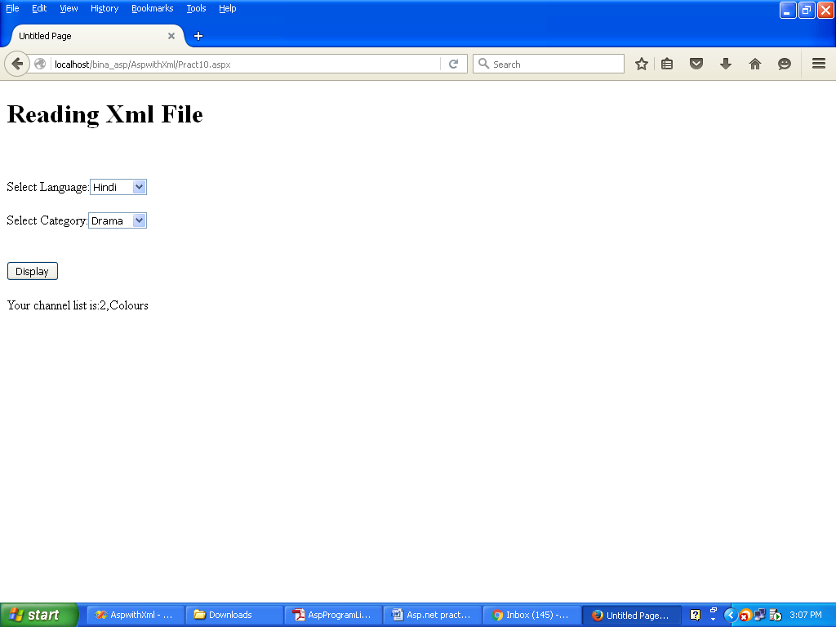

**PRACTICAL NO 11**

**AIM:**To study about AJAX.NET library in webpages

**INPUT:**

**Default.aspx**

<%@ Page Language="VB" AutoEventWireup="false" CodeFile="Default.aspx.vb" Inherits="_Default" %>

<!DOCTYPE html PUBLIC "-//W3C//DTD XHTML 1.0 Transitional//EN" "http://www.w3.org/TR/xhtml1/DTD/xhtml1-transitional.dtd">

<html xmlns="http://www.w3.org/1999/xhtml">

<head runat="server">

<title>Untitled Page</title>

</head>

<body>

<form id="form1" runat="server">

<div>

<center>

<h1>USING AJAX</h1>

<br />

<p>WELCOME TO <u>KHABRE DIN BHAR</u></p>

<asp:ScriptManager ID="ScriptManagerMatch" runat="server">

</asp:ScriptManager>

<hr />

<asp:UpdatePanel ID="UpdatePanelMatch" runat="server">

<ContentTemplate>

THE LATEST SCORE IS

<asp:Label ID="lblTime" runat="server"></asp:Label>

AT TIME

<asp:Label ID="lblScore" runat="server"></asp:Label>

<br />

<br />

<asp:Timer ID="TimerMatch" runat="server">

</asp:Timer>

<br />

<br />

<asp:Label ID="lblMsg" runat="server"></asp:Label>

</ContentTemplate>

</asp:UpdatePanel>

</center>

</div>

</form>

</body>

</html>

**Default.aspx.vb**

Imports System.Data

Imports System.Data.SqlClient

Imports System.Web.Configuration

Partial Class _Default

Inherits System.Web.UI.Page

Dim objcon As New SqlConnection(WebConfigurationManager.ConnectionStrings("DBConn").ConnectionString)

Protected Sub TimerMatch_Tick(ByVal sender As Object, ByVal e As System.EventArgs) Handles Timer1.Tick

Try

objcon.Open()

Dim strQuery As String = "Select max(MatchId) from Cricket"

Dim intflag As Integer

Dim objcmd As New SqlCommand(strQuery, objcon)

intflag = objcmd.ExecuteScalar

objcmd.CommandText = "Select Score from Cricket where MatchId=" & intflag

Dim objRead As SqlDataReader

objRead = objcmd.ExecuteReader

objRead.Read()

lblScore.Text = "<b>" & objRead(0) & "</b>"

lblTime.Text = "<b>" & DateTime.Now.ToString & "</b>"

Catch ex As Exception

lblMsg.Text = ex.Message.ToString

End Try

End Sub

End Class

**OUTPUT:**

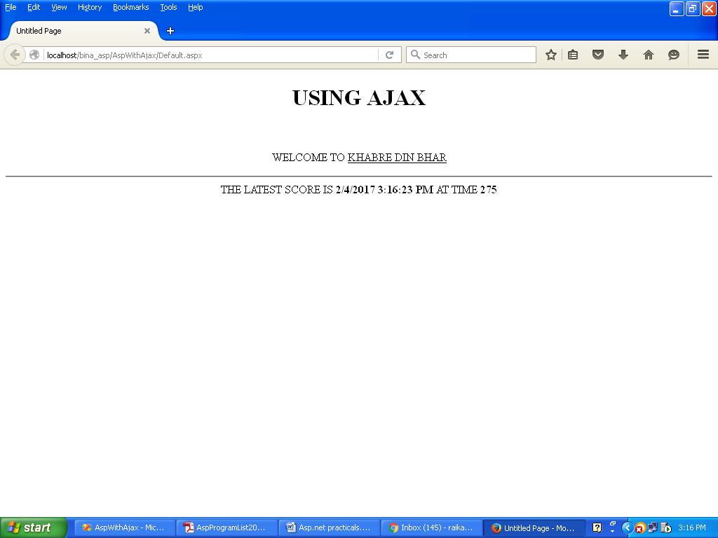

**PRACTICAL NO 12**

**AIM:** To study to create and use web services in asp.net

**INPUT:**

**MyWebSewrvice.vb**

Imports System.Web

Imports System.Web.Services

Imports System.Web.Services.Protocols

Imports System.Data

Imports System.Data.SqlClient

Imports System.Web.Configuration

' To allow this Web Service to be called from script, using ASP.NET AJAX, uncomment the following line.

' <System.Web.Script.Services.ScriptService()> _

<WebService(Namespace:="http://tempuri.org/")> _

<WebServiceBinding(ConformsTo:=WsiProfiles.BasicProfile1_1)> _

<Global.Microsoft.VisualBasic.CompilerServices.DesignerGenerated()> _

Public Class MyWebService

Inherits System.Web.Services.WebService

Dim strQuery, strResult As String

Dim dbRate As Double

Dim strcon As String = WebConfigurationManager.ConnectionStrings("AspwithWebServiceConnectionString").ConnectionString

Dim objCon As New SqlConnection(strcon)

<WebMethod()> _

Public Function HelloWorld() As String

Return "Hello World"

End Function

<WebMethod()> _

Public Function getPetrol(ByVal city As String) As String

strQuery = "Select Rate from PetrolRate where City=@city"

Dim objcmd As New SqlCommand(strQuery, objCon)

objcmd.Parameters.AddWithValue("@city", city)

objCon.Open()

Dim objRead As SqlDataReader = objcmd.ExecuteReader

objRead.Read()

strResult = objRead(0).ToString

objCon.Close()

Return strResult

End Function

<WebMethod()> _

Public Function getGold(ByVal city As String) As String

strQuery = "Select Rate from GoldRate where City=@city"

Dim objcmd As New SqlCommand(strQuery, objCon)

objcmd.Parameters.AddWithValue("@city", city)

objCon.Open()

Dim objRead As SqlDataReader = objcmd.ExecuteReader

objRead.Read()

strResult = objRead(0).ToString

objCon.Close()

Return strResult

End Function

<WebMethod()> _

Public Function getNSE() As String

strQuery = "Select * from NSE"

Dim objcmd As New SqlCommand(strQuery, objCon)

objCon.Open()

Dim objRead As SqlDataReader = objcmd.ExecuteReader

objRead.Read()

strResult = "<br> Opening Sensex" & objRead(0)

strResult &= "<br> Maximum Sensex" & objRead(1)

strResult &= "<br> Minimum Sensex" & objRead(2)

strResult &= "<br> Closing Sensex" & objRead(3)

objCon.Close()

Return strResult

End Function

<WebMethod()> _

Public Function getBSE() As String

strQuery = "Select * from BSE"

Dim objcmd As New SqlCommand(strQuery, objCon)

objCon.Open()

Dim objRead As SqlDataReader = objcmd.ExecuteReader

objRead.Read()

strResult = "<br> Opening Sensex" & objRead(0)

strResult &= "<br> Maximum Sensex" & objRead(1)

strResult &= "<br> Minimum Sensex" & objRead(2)

strResult &= "<br> Closing Sensex" & objRead(3)

objCon.Close()

Return strResult

End Function

End Class

**Main.aspx**

<%@ Page Language="VB" AutoEventWireup="false" CodeFile="Main.aspx.vb" Inherits="Main" %>

<!DOCTYPE html PUBLIC "-//W3C//DTD XHTML 1.0 Transitional//EN" "http://www.w3.org/TR/xhtml1/DTD/xhtml1-transitional.dtd">

<html xmlns="http://www.w3.org/1999/xhtml">

<head runat="server">

<title>Untitled Page</title>

</head>

<body>

<form id="form1" runat="server">

<div>

Select City for Gold Rate

<asp:DropDownList ID="ddlGoldRateCity"

runat="server" DataSourceID="sds1" DataTextField="City"

DataValueField="City" AutoPostBack="True"></asp:DropDownList>

<asp:SqlDataSource ID="sds1" runat="server"

ConnectionString="<%$ ConnectionStrings:AspwithWebServiceConnectionString %>"

SelectCommand="SELECT [City] FROM [GoldRate]"></asp:SqlDataSource>

<br /><br />

Select City for Petrol Rate

<asp:DropDownList ID="ddlPetrolRateCity"

runat="server" DataSourceID="sds2" DataTextField="City"

DataValueField="City" AutoPostBack="True"></asp:DropDownList>

<asp:SqlDataSource ID="sds2" runat="server"

ConnectionString="<%$ ConnectionStrings:AspwithWebServiceConnectionString %>"

SelectCommand="SELECT [City] FROM [PetrolRate]"></asp:SqlDataSource>

</div>

<b><u>NSE INDEX</u></b><asp:Label ID="LBLNSEIndex" runat="server"></asp:Label>

<br /><br />

<b><u>BSE INDEX</u></b><asp:Label ID="lblBSEIndex" runat="server"></asp:Label>

<br /><br />

<b><u>GOLD RATE IN</u></b><br /><asp:Label ID="lblGoldCity" runat="server"></asp:Label> &nbsp;IS <asp:Label ID="lblGoldRate" runat="server"></asp:Label>

<br /><br />

<b><u>PETROL RATE IN</u></b><br /><asp:Label ID="lblPetrolCity" runat="server"></asp:Label> &nbsp;IS <asp:Label ID="lblPetrolRate" runat="server"></asp:Label>

</form>

</body>

</html>

**Main.vb**

Partial Class Main

Inherits System.Web.UI.Page

Private MyWs As New localhost.MyWebService

Protected Sub Page_Load(ByVal sender As Object, ByVal e As System.EventArgs) Handles Me.Load

lblBSEIndex.Text = "<b>" & MyWs.getBSE & "</b>"

LBLNSEIndex.Text = "<b>" & MyWs.getNSE & "</b>"

End Sub

Protected Sub ddlGoldRateCity_SelectedIndexChanged(ByVal sender As Object, ByVal e As System.EventArgs) Handles ddltGoldRateCity.SelectedIndexChanged

lblGoldCity.Text = "<b>" & ddlGoldRateCity.SelectedItem.ToString & "</b>"

lblGoldRate.Text = "<b>" & MyWs.getGold(ddlGoldRateCity.SelectedItem.ToString) & "</b>"

End Sub

Protected Sub ddlPetrolRateCity _SelectedIndexChanged(ByVal sender As Object, ByVal e As System.EventArgs) Handles ddlPetrolRateCity.SelectedIndexChanged

lblPetrolCity.Text = "<b>" & ddlPetrolRateCity.SelectedItem.ToString & "</b>"

lblPetrolRate.Text = "<b>" & MyWs.getPetrol(ddlPetrolRateCity.SelectedItem.ToString) & "</b>"

End Sub

End Class

**OUTPUT:**

